SEND Policy

Created By: Curtis White
Approved By: Local Governing Board
Version: 1.0
Created: February 2023
Amended on: N/A
Created by: Headteacher
Amended by: N/A
Applies to: All staff, Members, Trustees and Governors
Next Review Date: February 2024

Contents
1. Purpose 1
2. Introduction 1
3. A Graduated Approach to SEND 1
4. Managing Needs of children with SEND 2
5. Supporting Children and families 5
6. Supporting children with medical needs 6
7. Monitoring and assessment 6
8. Training and Resources 6
9. Roles and Responsibilities 7
10. Storing and managing information 8
12. Monitoring, Evaluation and Review 8

Purpose

1.1 The purpose of this policy is to:

- To work within the guidance set out in the SEND Code of Practice 2014.
- To identify and provide for children who have special educational needs.
- To ensure that pupil voice is represented within this process. (move this higher up as this is the main focus of the SEND COP)
- To involve and support parents/carers at every stage in plans to meet their child’s additional needs. (move this higher up as this is the main focus of the SEND COP)
- To provide full access to the curriculum through quality first teaching and differentiated planning.
- To operate a whole school approach to the management and provision of support for children with SEND.
- To have a child centred approach throughout the Assess, Plan, Do, Review Cycle.

Introduction

2.1 At this Academy, as part of the INSPIRE MAT we are committed to a policy of educational inclusion whereby a supportive learning environment is provided.

2.2 We strongly believe in the role of quality first teaching and curriculum entitlement for all children to reach their full potential.

2.3 It is our aim for all children to have their diverse needs met, experience success and develop a feeling of self worth. All school staff are actively engaged in trying to match provision to the individual needs of all our children.

2.4 We recognise that some children have barriers to learning or significantly greater difficulty in learning and/or accessing the curriculum than others of their age. Teachers take into account these needs and make provision to support pupils to participate effectively in all aspects of academy life, through differentiation and reasonable adjustments where required

2.5 These difficulties may be long or short-term. These children are identified as having ‘Special Educational Needs and/or Disability’ (SEND). As we strive to achieve success for children with SEND we follow the guidance set out in the SEND Code of Practice 2014. Support is planned for individual children to help meet their needs and allow them to achieve positive outcomes in relation to their starting points. Types and levels of support will vary from child to child; support is no longer measured in hours of adult support provided

A Graduated Approach to SEND

3.1 The School has a graduated approach to meeting children’s educational needs. There are three waves of provision that can be provided to meet these needs:

3.2 Wave 1 Quality First Teaching Teachers are responsible and accountable for the progress and development of all the children in their class, including where children access support from teaching assistants or specialist staff in or outside of the classroom. This, for the majority of children, will be sufficient provision for them to make good progress.

3.3 Wave 2
Those making less than expected progress, given their age and individual circumstances, are identified. This can be characterised by progress which is:
- Significantly slower than that of their peers starting from the same baseline
- Fails to match or better the child’s previous rate of progress
- Fails to close the attainment gap between the child and their peers
- Widens the attainment gap

These children will require differentiated work or teaching methods within quality first wave teaching in order to make work accessible to them. This could take the form of more scaffolding in work, adaptations to meet individual learning style, additional adult support during the lesson or quality first teaching during ‘catch up’ based interventions aimed to close the gap in attainment between specific children and the age-related expectations.

Support may include some guidance from external agencies.

Wave 3
Few children will require work to be planned that is significantly different from their peers in difficulty or approach to teaching. These may require additional resources- both physical and/or human in order to make progress. All waves of provision are monitored regularly.

Support will include guidance and intervention from outside agencies

Managing Needs of children with SEND
4.1 The School follows the `assess, plan, do, review` process. Simply, this means we assess a child’s needs through discussion and observation, we then plan a strategy to meet their need and set a time scale in which we hope to see an impact. The strategy is implemented with the child and after the set time scale the impact is reviewed. The recommendations from an outside agency will be recKatorded on a ‘Support me to Learn’ plan.

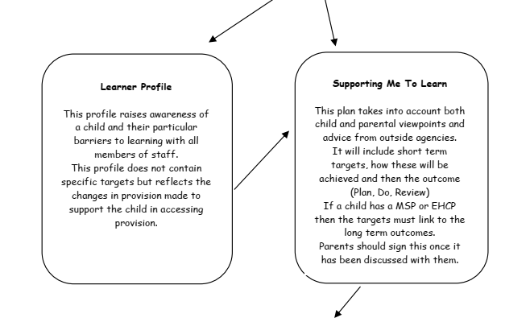
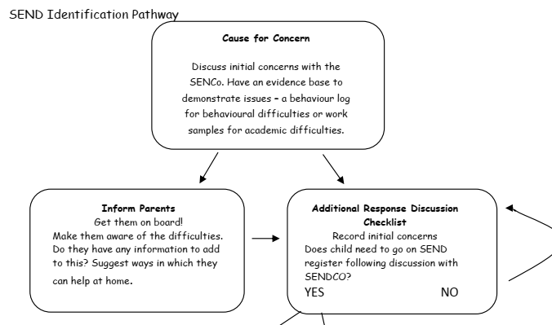
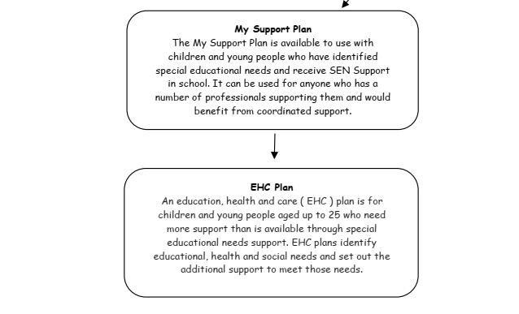

4.2 Step One: Additional Response
In deciding whether to make special educational provision, the teacher, parents and SENDCo will consider all of the information gathered from within the school about the child’s progress. Children are only identified as potentially having SEND if they do not make adequate progress once they have had all the intervention, adjustments and good quality personalised teaching. When it is decided that a child does have SEND, the decision is recorded in the schools SEND register and the child’s parents are informed that special educational provision is being made.

4.3 Step Two: SEND Support (Supporting Me to Learn Plan/Learner Profile)
All children on the SEND register who do not have a statement or EHCP will be classified as SEND Support in accordance with the SEND Code of Practice 2014. They will either be placed on a Supporting Me to Learn Plan or a Learner Profile at the discretion of their needs.

A Supporting Me to Learn Plan is a termly target record that specifies specific targets for a children with SEND needs to work towards. These steps are usually smaller to allow for the child to practice and apply these skills with independence. The Supporting Me to Learn Plan is reviewed termly (three times a year) and new targets are written, shared and agreed with the parents and pupils. Children may access external support where their targets can be written in collaboration with the specialists involved.

A Learner Profile may be used if a child doesn’t necessarily have learning difficulties but may have behavioural or emotional and/or mental health needs. This profile outlines what works best for a child and how they are best supported in and around the classroom.

4.4 SEND Support explained further
As part of the process of managing the level of support needed for children at SEND Support the school has two to three planning meetings each year with a representative from LSS, EPS, CIAT and SEMHs as well as two consultation meetings. Planning meetings are an opportunity to discuss children in school and their needs without being specific about children. It is an opportunity for the SENDCo and class teachers to gather information and advice that can feed into their planning to meet a child’s needs. Consultation meetings are a chance to talk about specific children and their needs with a view to potentially needing specific individual support from an outside agency. All external agencies will offer strategies to try and monitor. It is good practice for schools to discuss pupils with outside agencies. The expectation is that pupils will have been discussed on at least 2 prior occasions with outside agencies before support can be accessed, however, in urgent cases support can be accessed more swiftly.

If the strategy has not had the desired impact on the child’s progress, and no circumstances can explain this, then the process will be repeated again with a new strategy. At this point it may be that the strategy is from the next wave of the graduated approach.

For children with more complex needs, support in this process will be requested from outside specialist agencies such as:
  - WISENDSS (formerly known as: CIAT - Communication and Interaction Team; LSS - Learning Support Service; SEMHT - Social, Emotional and Mental Health Team)
  - EPS - Educational Psychology Service
  - CAMHS - Child and Adult Mental Health Service
  - School Nursing.

All children at SEND support are monitored closely to check the provision planned by the class teacher is having a positive and significant impact on their progress. The Supporting Me to Learn Plan/Learner Profile reviews outline the level of success and need for the individual child.

4.5 Step Three: My Support Plan
Children at SEND support with additional outside agency support who have particularly complex needs may have lots of different outside agencies involved in planning their provision will also have a `My Support Plan` completed over the next year in line with Wakefield Authorities SEND model of support. These will be completed through collaboration of the SENDCo, the parents/guardians, the child and specialist advice and involvement. If a child requires additional Support then the agreed decision to seek additional support would be agreed. The process for statutory assessment of an EHCP would begin.

4.6 Step Four: Education Health and Care Plan (EHCP)
A small number of children, whose needs are complex and long term, may require a greater level of support. Where, despite a school having taken the relevant action to identify, assess and meet the needs of a child the child has not made expected progress, the school and parents/carers should consider applying for an EHCP. For these children a request will be made to SENART to conduct an assessment of education, health and care needs. This may result in an Education, Health and Care (EHC) plan being provided. This brings together the child’s health and social care needs as well as their Special Educational Needs and/or Disability.

The decision to apply to SENART for an EHCP will usually take place at a ‘My Support Plan’ meeting in school. During these meetings agreed long term outcomes are identified and these are monitored and regularly reviewed. The evidence collected through My Support Plan forms the basis for applying for an EHCP if necessary. EHC plans will be used to actively monitor children’s progress towards their outcomes and longer-term aspirations. They must be reviewed by the local authority, as a minimum, every 12 months.

4.7 Children with an EHCP
All children with an EHCP will receive an annual review of that plan in a review meeting chaired by the SENDCo. All parties involved with assessing, planning, implementing or reviewing the child’s needs will be invited to the meeting by the SENDCo. In the review, the child’s current needs will be discussed and documented. Both long term and short term targets will be reviewed and new targets set. The ‘assess / plan / do/ review’ cycle will still continue, and further agencies and professionals may get involved. These will be noted on their Supporting Me to Learn Plan. This will outline key targets for the following term set through collaboration with the class teacher, the parents/carers and the child. Targets will be based on wanted outcomes for the child, they will relate to the child’s needs not just academic progress. These will be reviewed at 3 points during the year. Parents are invited to be part of this process.

For pupils transferring from Y6 to Y7 and moving to another setting for the next phase in their education, the annual review cycle must be completed earlier in the year and before 31st October (during Autumn Term 1).

4.8 Criteria for exiting the SEND register
The SEND register is a flexible register. If children, when having received appropriate identified support, begin to make good progress and close the gap with their peers, they can, in consultation with parents, come off the SEND register. If the child’s needs are being managed successfully within the classroom with no different from or additional to support then the child no longer needs to be classed a SEND Support.

Supporting Children and families

5.1 The schools SEND Information Report (Local Offer) is available on our website for parents to access. The school also offers access to our: accessibility policy, auxiliary aids policy, admissions policy and medicine policy.
School have links with other agencies which support the family and child.
A transition process takes place for those children moving into school, moving between classes and into secondary school. Arrangements are made for all children but additional arrangements are put in place for those children who have Special Educational Provision, these are adapted to the needs of the child.

The Local Authority has a Parent Partnership Service for the parents/carers of any child with SEND that provides advice and information about matters relating to those special educational needs and disabilities. Parents can also access support from Barnardo’s.

Supporting children with medical needs

6.1 The School recognises that children at school with medical conditions should be properly supported so that they have full access to education, including school trips and physical education. Some children with medical conditions may be disabled and where this is the case the school will comply with its duties under the Equality Act 2010.

Some may also have special educational needs (SEND) and may have a statement, or Education, Health and Care (EHC) plan which brings together health and social care needs, as well as their special educational provision and the SEND Code of Practice (2014) is followed.

Specific personalised arrangements are put in place in school to support children with medical conditions.

Monitoring and assessment
7.1 Class teachers, supported by the Senior Leadership Team, assess progress of all children termly. The Senior Leadership Team regularly and carefully review the quality of teaching for all, including those at risk of underachievement through classroom observations, monitoring of books and by talking to the children themselves.

Assessments of child progress will be individualised where possible to suit the learning needs of the child. The progress of some of our children with SEND may not be fully captured as they may make smaller steps. In order to ensure that we can monitor this progress and identify next steps of children with SEND who are working below the age-related expectations for Year 2 we will be using the Wakefield Progression Steps documentation. We also use the Birmingham Continuum to monitor the progress and identify the next steps of children with SEND who are working below ARE but who have achieved the Year 2 standard.

Training and Resources

8.1 In order to meet the diverse needs of all children, the staff will need access to training. The Trust is committed to the ongoing training of all staff, and within the Trust, good practice is shared. Individual Academies keep records of the qualifications and training of support staff. This helps in matching children’s needs and in making sure that all staff are kept up to date with new initiatives and have access to appropriate training. The SENDCo in each academy is proactive in identifying any training needs.

Roles and Responsibilities

9.1 The Governing Body
Our SEND named governor is Kate Gawthorp.

The Governing Body, in consultation with the Head Teacher, determines the application of the Trust’s SEND Policy and approach to provision for children with special educational needs, within their own academy. They are also responsible for establishing the appropriate staffing and funding arrangements and maintaining a general overview of the school’s work. This will be supported by a termly update on the progress of SEND pupils in the Headteachers Report to the Local Governing Body. (minimum expectation).

The Governing Body, having regard to the Code of Practice:
- Ensure appropriate provision is made for any child with SEND
- Reports annually to parents on the school’s policy for children with SEND
- Ensure all children, including those with SEND have access to a broad, balanced and appropriately differentiated curriculum
- Appoints a representative of the Governing Body to oversee SEND provision
- Ensure discussions with parents regarding SEND matters at relevant meetings
- Ensure that children with SEND are fully involved with school activities
- Ensure they are fully involved in developing and reviewing SEND Policy.

The Principal / Head of School
The Principal/Head of School is responsible for the day-to-day management of all aspects of the school’s work, including provision for special educational needs. The Principal/Head of School keeps the Governing Body informed of all developments with regard to SEND. The Principal/Head of School informs parents of the fact that SEND provision has been made for their child.

SENDCos
The SENDCo for Gawthorpe Community Academy is Jess Darby
The Code of Practice states that the role of a SENDCo is:
- Overseeing the day-to-day operation of the school’s SEND policy
- Coordinating provision for children with SEND
- Liaising with the relevant Designated Teacher where a looked after child has SEND
- Advising a on graduated approach to providing SEND Support
- Advising on the deployment of the school’s delegated budget and other resources to meet children’s needs effectively
- Liaising with parents of children with SEND
- Liaising with early years providers, other schools, educational psychologists health and social care professionals, and independent or voluntary bodies
- Being a key point of contact with external agencies, especially the LA and LA support services
- Liaising with potential next providers of education to ensure a young person and their parents are informed about options and a smooth transition is planned
- Working with the head teacher and school governors that the school meets its responsibilities under the Equality Act (2010) with regard to reasonable adjustments and access arrangements
- Ensure that the school keeps the records of all children with SEND up to date.

The SENDCo must be a qualified teacher. A newly appointed SENDCo must be a qualified teacher and where they have not previously been the SENDCo at that or any other relevant school for a total period of more than 12 months they must achieve the NASEN qualification within three years of appointment.

Teachers Will:
- Be responsible for delivering quality first teaching to all pupils in their class.
- Be aware of the school’s procedures for the identification and assessment of, and subsequent provision for, children with SEND.
- Work with the SENDCo to decide the action required to assist the child to make progress.
- Work with the SENDCo to collect all available information on the child.
- Develop and review paper based plans for children in consultation with the SENDCo, parents and the child. (see SEND pathway).
- Work with SEND children on a daily basis to deliver the individual programme set out on the Trust’s documentation.
- Develop effective relationships with parents.
- Encourage children to participate in decision-making.
- Be involved in the development and review of the school’s SEND policy.
- Continuously assess child progress and identify the next steps to learning.
- To keep parents informed of child progress.
- Work with the SENDCo to identify their own training needs around SEND.

Teaching Assistants Will
- Provide relevant support to identified children
- Support children to become independent learners in preparation for adulthood
- Develop positive working relationships with parents and professionals
- Assist with the recording, monitoring and evaluation of children’s progress
- Assist with the identification and effective provision of appropriate resources
- Attend liaison, team and service meetings and undertake appropriate INSET
- Work in collaboration with the SENDCo, teaching staff, parents and the child in the preparation of relevant documentation

10. Storing and managing information

11.1 All information is stored and shared in line with the confidentiality policy. The minimum retention period for documentation is 25 years after the child’s date of birth. At this time each case is reviewed individually due to legal proceedings. If there are no legal proceedings documentation will be destroyed.

External Agencies provide parents with a copy of their GDPR policies in advance of their permission to request support. This allows parents to fully understand how external parties will store and use their child’s data.

12. Monitoring, Evaluation and Review

12.1 The SEND policy will be reviewed annually and may be amended prior to this if significant reforms are implemented. A current policy will be available on the school website or by request at the school office.

We recognise that from time to time there may be difficulties or differences of opinions when accommodating children with SEND. The school will try to resolve any problems that arise, but will signpost parents to alternative support such as the Parent Partnership Service or the LA, should this be necessary. The school’s complaints procedure can be requested at the main office. The SEND Code of Practice outlines additional measures the LA must set up for preventing and resolving disagreements. Parents/carers will be given the necessary information upon request.

Signature
Headteacher :

Signature
Chair of Local Governing Body :

Date : | 21.02.23

