Using representations to support maths teaching guidance

Representation | Guidance | EY | KS1 | KS2
Place Value
Place Value Chart and counters  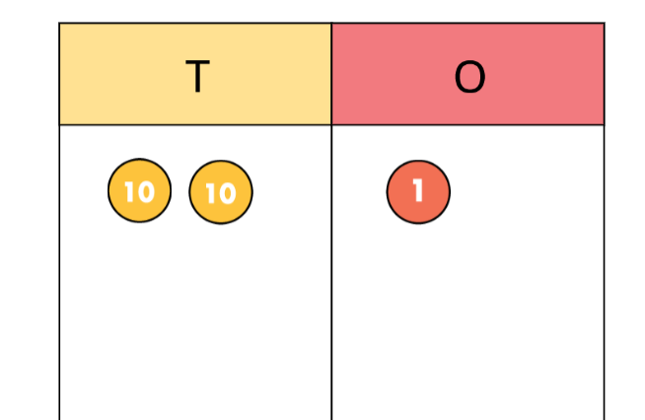  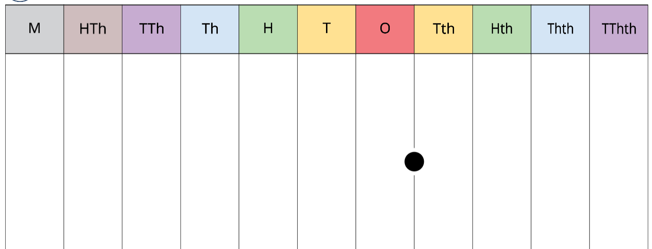 | Place Value Chart (whiterosemaths.com) | ✓ | ✓ | ✓
Gattegno chart  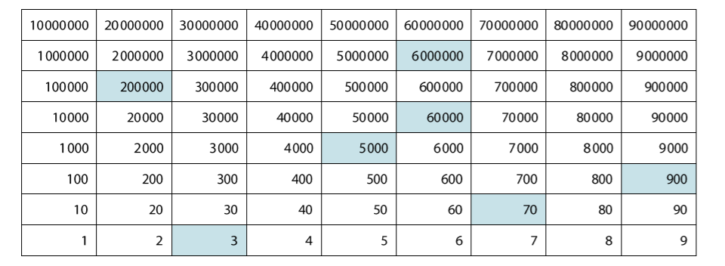 | The Gattegno chart highlights the structure of numbers. The organisation is similar to a place value chart but the numbers are organised according to their ordinality, making the structure visible and supporting language of number.  For place value, numbers can be read and written down, recognising the partitioned form. Children can represent numbers on the chart.  This supports recognising 0 as a place holder.  Gattegno Tens Chart (mathsbot.com) |  |  | ✓
Addition and Subtraction
Part-Whole Model  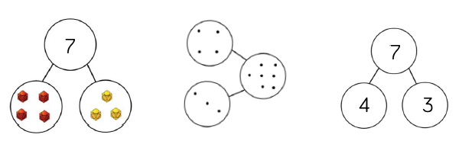  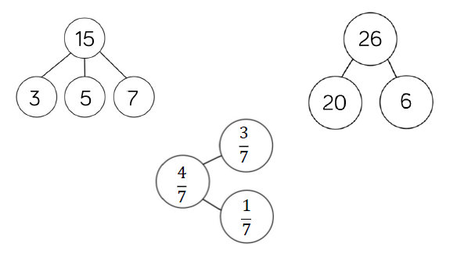 | PW model supports understanding of aggregation and partitioning into two or more parts.  Aggregation – parts complete and whole empty.  Partitioning – whole complete and at least one part empty.  Use alongside abstract models. | ✓ | ✓ | ✓
Bar Model  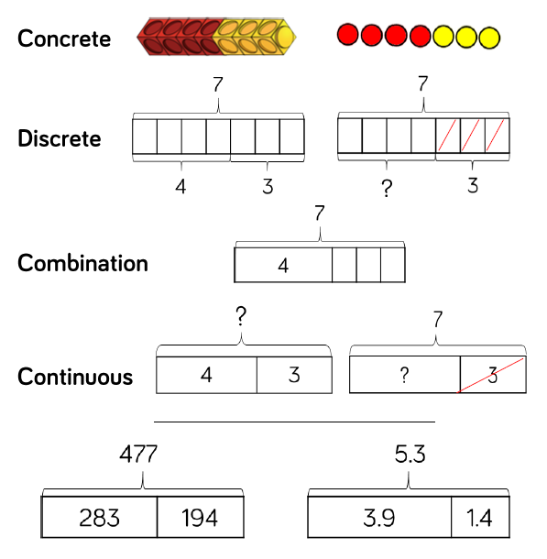  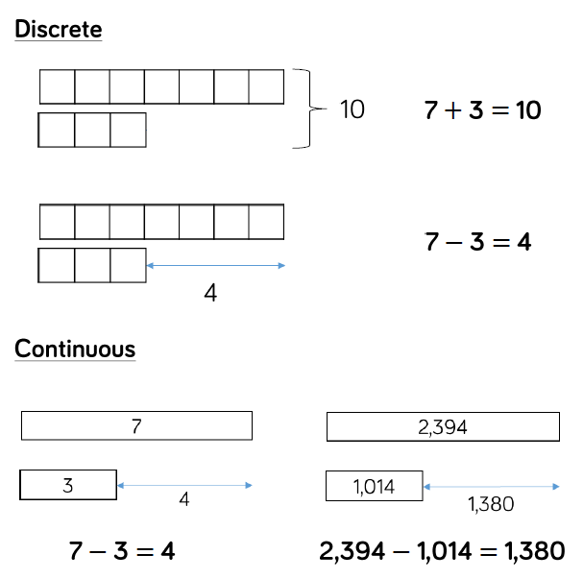 | Single  Part whole model to support the children in representing calculations. Cubes and counters can be used as a concrete resource.  Discrete – each box represents one whole.  Combination – Counting on from larger number.  Continuous – Each rectangle represents a number and question mark indicates the part to be found.  Multiple  A helpful model to compare quantities. Two or more bars can be drawn here using a bracket to label the whole at the side. As with single models, discrete bars can represent smaller numbers ad continuous for bigger quantities.  Multiple bars can represent difference in subtraction with the arrow modelling the difference.  Bar Model (whiterosemaths.com) | ✓ | ✓ | ✓
Numicon  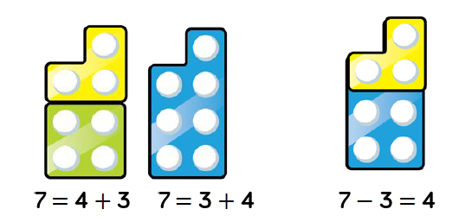 | Numicon supports children in subitising and exploring aggregation, partitioning and number bonds.  Children can visibly see how numbers come together to make a whole and can start with the whole when subtracting, covering part of the whole to see what is missing. The more children work with this resource, the more opportunities they have to subitise due to familiarity.  Children can work systematically to find number bonds, exposing the composition of each number.  Number Frames (mathsbot.com) | ✓ | ✓ | ✓
Clothes pegs  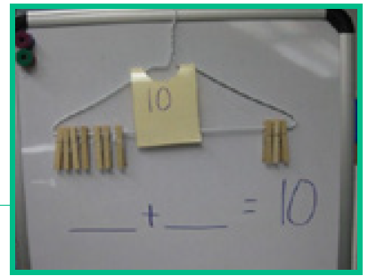 | Wooden or plastic clothes pegs are a good resource for teaching number bonds. You can attach to hangers to look at number bonds, write questions on them and get children to attach answers to them. | ✓ | ✓
Cubes  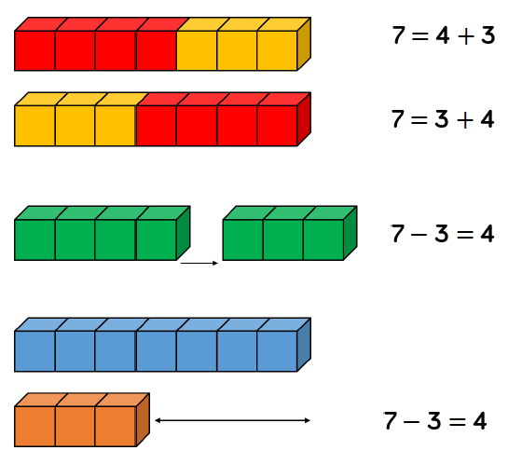 | Addition and subtraction of 1-digit numbers, seeing how marts come together to make the whole. Two different colours can be used to represent each whole. When subtracting, children can remove the amount being subtracted using the reduction (take away) concept. When finding the difference, cubes can be lined up similar to the discrete bar model representations to find the difference. | ✓ | ✓ | ✓
Ten frames  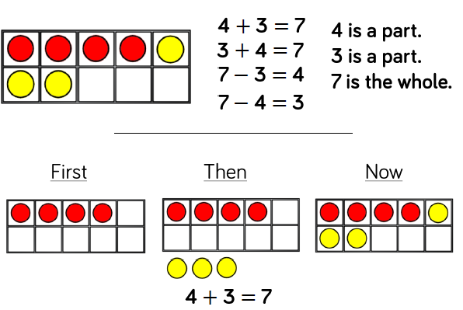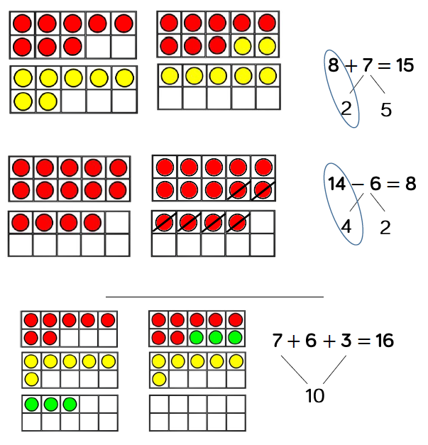  Ten Frame (mathsbot.com) | Within 10  Children will develop their understanding of structures of addition and subtraction. Use the language of parts and wholes represented by objects, children are able to find all the number bonds for a number.  Aggregation – addition where parts come together to make a whole.  Partitioning – subtraction where the whole is split into two parts.  Children ca use these alongside a story to represent the maths using a first, then, now structure for augmentation or reduction.  Augmentation – increasing a number.  Reduction – taking away.  Within 20  To add two single digits, children make each number on a separate frame and then moving part of the number to make a whole 10. This represents partitioning a number to make a bond to 10, embedding effective mental methods. When subtracting, make the larger number and remove the smaller number, exposing how the smaller number has been partitioned to make 10.  Using know facts  Children can unitise each counter to support their understanding on bonds to 100 or decimal numbers. Each counter may represent 100 or 0.1. | ✓ | ✓ | ✓
Number lines  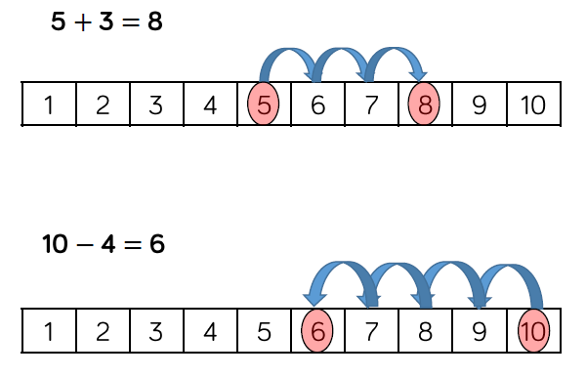  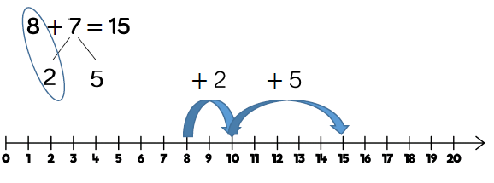  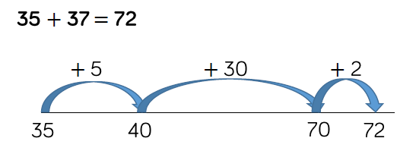 | When adding, children count to find the total of the numbers.  When subtracting, children count back to find their answer, starting at the minuend and taking away the subtrahend to find the difference.  Use these alongside 10 frames to model counting on and back.  For younger children, board games will allow children to become familiar.  For older children, children can add by jumping to the nearest 10 and adding the rest of the number.  Number Line (mathsbot.com) | ✓ | ✓ | ✓
Straws  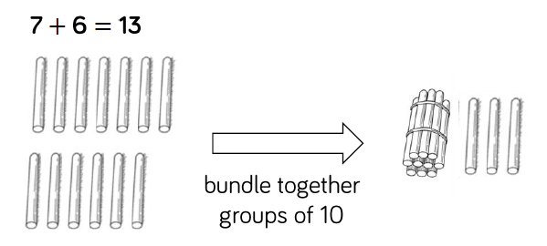 | Straws support children in understanding of exchange when adding and subtracting 2 digits. Children bundle groups of 10, using bands to tie their bundles.  When adding numbers, children bundle a group f 10 to show the exchange from 10 ones to 1 ten. They then add the remaining individual straws (ones).  When subtracting numbers, children unbundle a group of straws to represent the exchange from one 10 to 10 ones.  Straws are a good stepping stone into using Dienes. | ✓ | ✓
Dienes  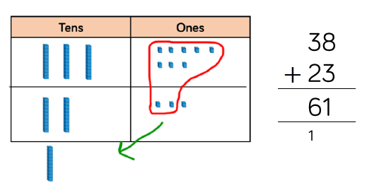  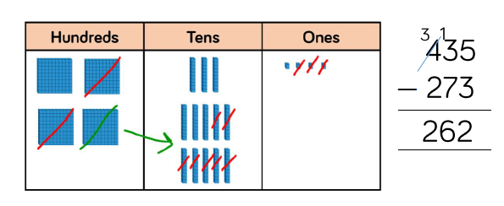 | Dienes support with exchanging and column addition and subtraction. Children should be encouraged to write out their calculations alongside the concrete to make clear links.  First add without an exchange to become familiar. Add the smallest value first, working from right to left using these questions to prompt:  - How many ones altogether?  - Can we make an exchange?  - How many do we exchange?  - How many additional ones do we have left?  When subtracting, children should make the minuend with the Dienes and then subtract the subtrahend. Starting with the smallest place value and working from right to left.  NB: this representation becomes less efficient with larger numbers due to the size of the resources, please see place value counters.  Dienes Blocks (mathsbot.com) | ✓ | ✓ | ✓
Place value counters  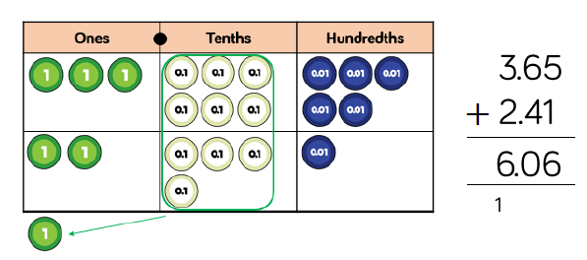  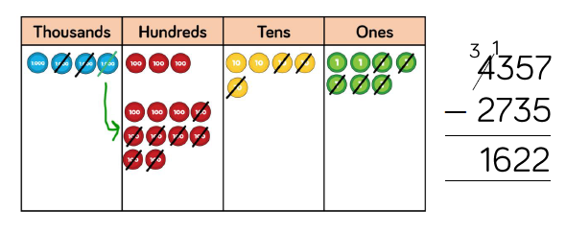 | Place value counters support column addition and subtraction. Children should be encouraged to write out their calculations alongside the concrete to make clear links. Different counters can be used to represent larger numbers and decimal numbers.  First add or subtract without an exchange to become familiar. Begin with the smallest value first, working from right to left.  When subtracting, children should make the minuend and then subtract the subtrahend. Starting with the smallest place value and working from right to left.  When adding and subtracting money, children can use coins to support their understanding. Emphasis should be placed on how coins link to the written calculation when adding decimals.  Place Value Counters (mathsbot.com) |  | ✓ | ✓
Multiplication and Division
Bar Model  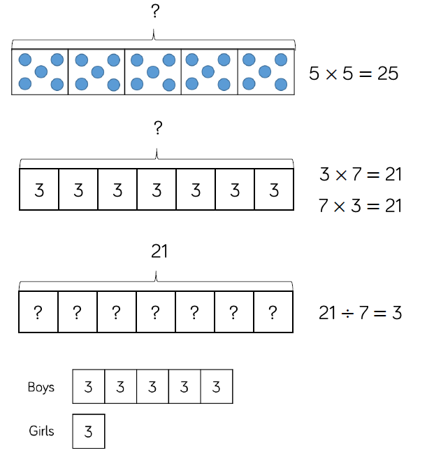 | Single bar – multiplication as repeated addition. Counters, cubes or dots can support calculation before replacing these with abstract digits.  Division can be represented showing the total of the bar and dividing the bar into equal parts.  In scaling, more than one bar model is useful to represent the type of problem. In this case, the multiple bar model provides an opportunity to compare groups. E.g. There are 3 girls in a group. There are 5 times as many boys as girls. How many boys are these?  NB: Bar models must represent the worded problem being solved.  Bar Model (whiterosemaths.com) |  | ✓ | ✓
Numicon  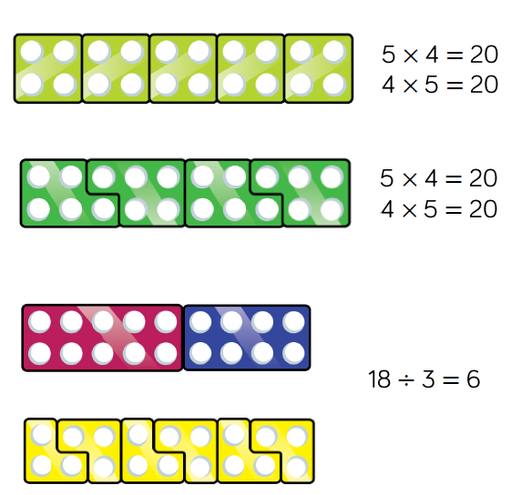 | Multiplication as repeated addition.  Multiplications can be built in a row by using the Numicon. With odd numbers, shapes can be interlocked so there are no gaps. Numicon can be used to see patterns of multiplication e.g. odd x odd = even, odd x even = odd, even x even = even.  When dividing, expose the children to grouping. Children make the dividend and place the number of the divisor over the shape to find how many groups there are altogether. E.g. 6 groups of 3 in 18.  Number Frames (mathsbot.com) | ✓ | ✓ | ✓
Number lines  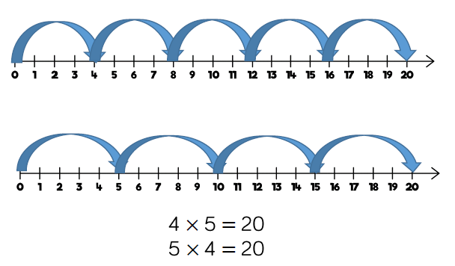  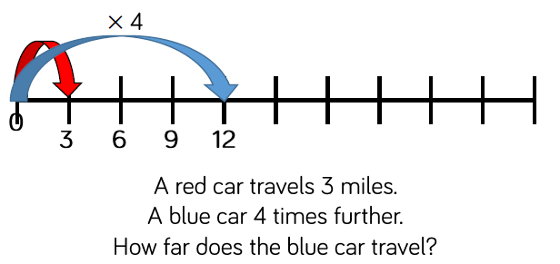 | Children use number lines to count forward or backwards in multiples.  Moving counters or cubes along the line can support children with accuracy of their counting. Translucent counters help the children see the number they are landing on.  When multiplying, children place a counter on 0 and count to find the product of their numbers.  When dividing, place a counter on the dividend and count back in jumps of the divisor until reaching 0, recording how many jumps.  NB: Number lines are less efficient with larger numbers.  Blank number lines can support with scaling as multiplication or division. Blank number line with intervals can support children to represent scaling accurately. Children label the intervals with multiples to calculate scaling problems.  Number Line (mathsbot.com) | ✓ | ✓ | ✓
Dienes  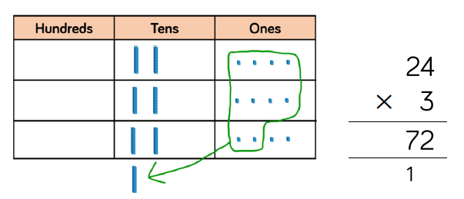  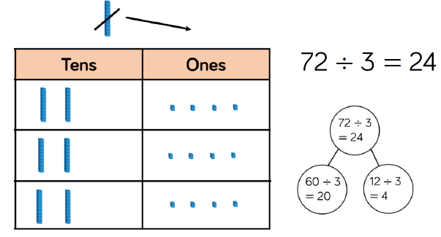 | Dienes support with column multiplication and division. Children should be encouraged to write out their calculations alongside the concrete to make clear links.  When they are sharing, children start with the larger place value and work from left to right. If any are left in a column, they exchange. When recording, encourage a part-whole model along side the Dienes to consider how the number has been partitioned in order to divide. This supports with mental methods.  NB: as numbers become bigger, Dienes become less efficient due to size of equipment.  Dienes Blocks (mathsbot.com) |  | ✓ | ✓
Place value counters  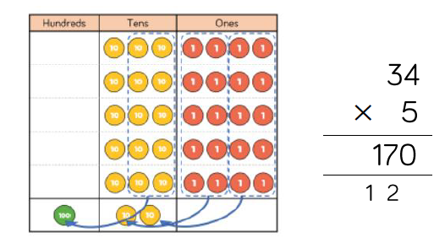  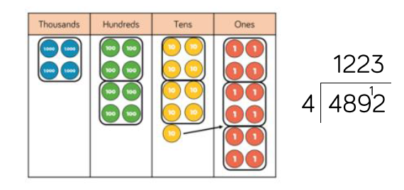 | Place value counters support column multiplication and division. Children should be encouraged to write out their calculations alongside the concrete to make clear links.  With multiplication, counters should be used to support the written method rather than supporting the arithmetic. Place value counters can also support the area model.  With smaller numbers in division, children share between groups starting with the largest digits and exchanging when any are left over. This can be linked with part-whole model to show their thinking and understanding of partitioning.  For short division, children group the counters rather than sharing them, working from left to right with any left over counters exchanged.  Different counters can be used to represent larger numbers and decimal numbers.  Place Value Counters (mathsbot.com) |  | ✓ | ✓
Gattegno Chart  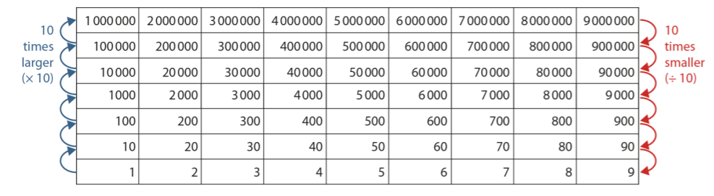 | A general way to work with the chart is to point and tap a number with the whole class calling back a response in unison.  “I am going to point to a number and you have to multiply it by 10.”  Point to 3, then 7, then 40, then 60, then 80, then 500, then 0.7 then 0.03.  “What makes this easy to do? What about the chart makes this easy to do?”  Gattegno Tens Chart (mathsbot.com) |  |  | ✓
Fractions and percentages
Number lines  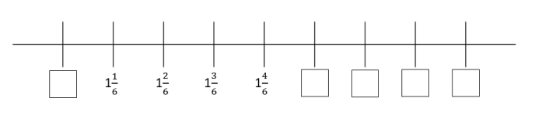 | Children count up and down in a given fraction. They continue to use visual representations to help them explore number sequences. Children also find missing fractions in a sequence and determine whether the sequence is increasing or decreasing and by how much  Number Line (mathsbot.com) |  | ✓ | ✓
Bar models  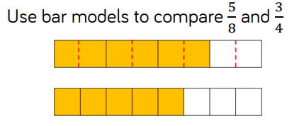  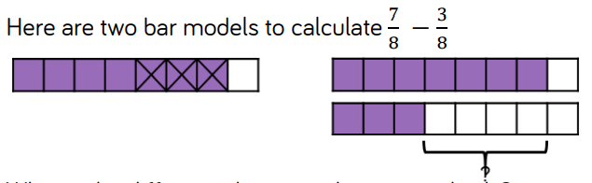  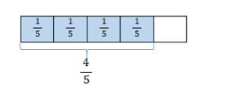 | Children compare the fractions by finding a common denominator or a common numerator. They use bar models to support their understanding.  Children use bar models to support understanding of adding and subtracting fractions.  Multiplication can be linked to repeated addition, children can see that the denominator remains the same, whilst the numerator is multiplied by the integer. This is shown clearly through the range of models to build the children’s conceptual understanding of multiplying fractions.  Bar Model (whiterosemaths.com) |  | ✓ | ✓
Part Whole Model  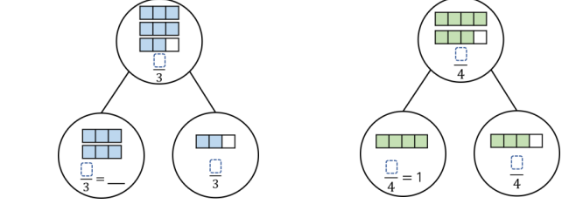 | Children use manipulatives and diagrams to show that a fraction can be split into wholes and parts.  Children focus on how many equal parts make a whole dependent on the number of equal parts altogether. |  | ✓ | ✓
Gattegno chart  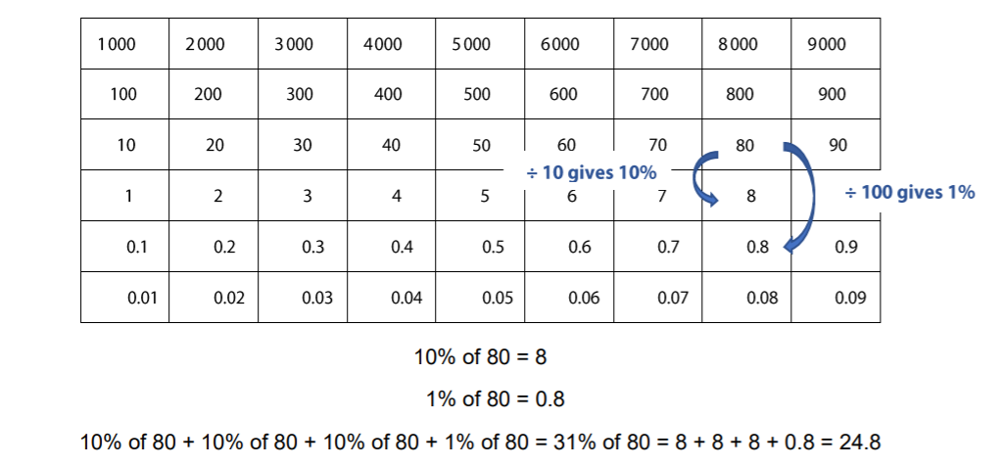 | The Gattegno chart can be used to find percentages of amounts using the mathematical facts that finding 10% of an amount is the same as dividing by 10 and finding 1% of an amount is the same as dividing by 100.  Students may also recognise that dividing by 10 and then dividing by 10 again is the same as finding 1%.  Students may then go on to identify ways to find 5% and 20%  Gattegno Tens Chart (mathsbot.com) |  |  | ✓
Models  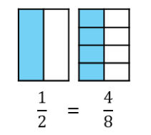  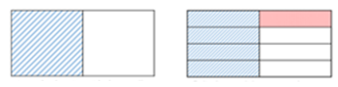 | Children explore equivalent fractions using models and concrete representations. They use models to make the link to multiplication and division.  Children then apply the abstract method to find equivalent fractions. It is important children have the conceptual understanding before moving on to just using an abstract method.  Children use strip diagrams to investigate and record equivalent fractions. They start by comparing two fractions before moving on to finding more than one equivalent fraction on a fraction wall.  Children add fractions with different denominators where one denominator is a multiple of the other or common multiples are found. They can use pictorial representations to convert the fractions so they have the same denominator.  NB: Ensure children always write their working alongside the pictorial representations so they see the clear links. | ✓ | ✓ | ✓
Fraction wall  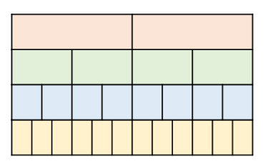 | A fraction wall is a visual representation to help students learn, compare and identify fractions, set out in the form of a wall. This is a great way to help students begin to understand the basics of fractions.  The fraction wall can really help children visualise what fractions are, the relationship they have with each other, and the link between fractions, multiplication and division, which will give them a solid foundation as they move forward.  Fraction Wall (mathsbot.com) |  |  | ✓

