Gawthorpe Community Academy

Science Progression Grid
Children have the opportunity to work scientifically throughout each each unit of work to develop their understanding and knowledge. Each academic year, students will study topics within the three broad areas of Biology, Physics and Chemistry. An exemplar series of lessons is available to support staff in developing these units of work and, over time, pupils’ knowledge and skills in science.

 | At Key Stage One:  During years 1 and 2, pupils should be taught to use the following practical scientific methods, processes and skills through the teaching of the programme of study content:  - asking simple questions and recognising that they can be answered in different ways  - observing closely, using simple equipment  - performing simple tests  - identifying and classifying  - using their observations and ideas to suggest answers to questions  - gathering and recording data to help in answering questions | At Lower Key Stage Two:  During years 3 and 4, pupils should be taught to use the following practical scientific methods, processes and skills through the teaching of the programme of study content:  - asking relevant questions and using different types of scientific enquiries to answer them  - setting up simple practical enquiries, comparative and fair tests  - making systematic and careful observations and, where appropriate, taking accurate measurements using standard units, using a range of equipment, including thermometers and data loggers  - gathering, recording, classifying and presenting data in a variety of ways to help in answering questions  - recording findings using simple scientific language, drawings, labelled diagrams, keys, bar charts, and tables  - reporting on findings from enquiries, including oral and written explanations, displays or presentations of results and conclusions  - using results to draw simple conclusions, make predictions for new values, suggest improvements and raise further questions  - identifying differences, similarities or changes related to simple scientific ideas and processes  - using straightforward scientific evidence to answer questions or to support their findings | At Upper Key Stage Two:  During years 5 and 6, pupils should be taught to use the following practical scientific methods, processes and skills through the teaching of the programme of study content:  - planning different types of scientific enquiries to answer questions, including recognising and controlling variables where necessary  - taking measurements, using a range of scientific equipment, with increasing accuracy and precision, taking repeat readings when appropriate  - recording data and results of increasing complexity using scientific diagrams and labels, classification keys, tables, scatter graphs, bar and line graphs  - using test results to make predictions to set up further comparative and fair tests  - reporting and presenting findings from enquiries, including conclusions, causal relationships and explanations of and a degree of trust in results, in oral and written forms such as displays and other presentations  - identifying scientific evidence that has been used to support or refute ideas or arguments
 | Science Tier 3 Vocabulary @ KS1: | Science Tier 3 Vocabulary @ LKS2: | Science Tier 3 Vocabulary @ UKS2:
 | observe, observing, identify, classify, diagram, chart, map, data, contrast, biology, chemistry, physics, | research, scientific enquiry, comparative and fair test, conclusion, predictions, differences, similarities, evidence, guides, keys, construct, interpret | variables, precision, repeat readings, classification keys, causal relationship, explanations, degree of trust, quantitative measurements

Science in the  Early Years  Framework 2021 | Nursery | Reception
 | - Make collections of natural objects and talk about different types of leaves, seeds, rocks etc  - Observational and investigative skills – I wonder if…  - Plant seeds and care for growing plants  - Show and explain concepts of growth, change and decay e.g. observe an apple going brown and mouldy over time  - Help children care for animals and take part in first hand explorations of life cycles e.g.  caterpillars or chicks.  - Understand the key features of lifecycle of a plant/animal  - Explore and talk about forces we n feel e.g. magnetic attraction and repulsion, how water pushes up when you push a boat under it  - Explore how materials float and sink  - Talk about differences in materials and how they change e.g. melting and cooling - Explore how light can shine through some materials and not others.  - Investigate shadows | - Opportunities to use senses to observe  - Sing songs and rhymes about the natural world  - Draw pictures of the natural world after close observation, including animals and plants  - Observe and interact with natural processes e.g. ice melting, sound causing vibration, light travelling through transparent material, object casting a shadow, magnet attracting an object and a boat floating on water.  - Focused observations of the natural world  - Describe and comment on things they have seen, including plants and animals.  - Name and describe some plants and animals that children are likely to see  - Teach children about a range of contrasting environments  - Vocabulary to name specific features both natural and man made.  - Understand the effect of changing seasons.  - Draw attention to weather and seasonal features  - Provide opportunities for children to note and record the weather.  - Share texts about the changing seasons  - Observe how animals behave differently as the seasons change.

The Key Stage One curriculum builds on the foundation work completed throughout Early Years. The following progression highlights ‘expected’ level for areas of the Science curriculum which is woven throughout the different aspects of Early Years curriculum:

Biology - Animals including humans
 | Year 1 |  | Year 2 | Year 3 |  | Year 4 |  | Year 5 | Year 6
Knowledge | - identify and name a variety of common animals including fish, amphibians, reptiles, birds and mammals  - identify and name a variety of common animals that are carnivores, herbivores and omnivores  - describe and compare the structure of a variety of common animals (fish, amphibians, reptiles, birds and mammals including pets)  - identify, name, draw and label the basic parts of the human body and say which part of the body is associated with each sense |  | - notice that animals, including humans, have offspring which grow into adults  - find out about and describe the basic needs of animals, including humans, for survival (water, food and air)  - describe the importance for humans of exercise, eating the right amounts of different types of food, and hygiene | - identify that animals, including humans, need the right types and amount of nutrition, and that they cannot make their own food; they get nutrition from what they eat  - identify that humans and some other animals have skeletons and muscles for support, protection and movement | - describe the simple functions of the basic parts of the digestive system in humans  - identify the different types of teeth in humans and their simple functions  - construct and interpret a variety of food chains, identifying producers, predators and prey |  |  | • describe the changes as humans develop to old age | - identify and name the main parts of the human circulatory system, and describe the functions of the heart, blood vessels and blood  - recognise the impact of diet, exercise, drugs and lifestyle on the way their bodies function  - describe the ways in which nutrients and water are transported within animals, including humans
Skills | Secure  - Can they point out some of the differences between different animals?  - Can they sort photographs of living things and non-living things?  - Can they identify and name a variety of common animals?  (birds, fish, amphibians, reptiles, mammals, invertebrates)  - Can they describe how an animal is suited to its environment?  - Can they identify and name a variety of common animals that are carnivores, herbivores and omnivores  - Can they name the parts of the human body that they can see?  - Can they draw & label basic parts of the human body?  - Can they identify the main parts of the human body and link them to their senses?  - Can they name the parts of an animal’s body?  - Can they name a range of domestic animals?  - Can they classify animals by what they eat? (carnivore, herbivore, omnivore)  - Can they compare the bodies of different animals?  Extend  - Can they begin to classify animals according to a number of given criteria?  - Can they point out differences between living things and non-living things?  - Can they name some parts of the human body that cannot be seen?  - Can they say why certain animals have certain characteristics?  - Can they name a range of wild animals? |  | Secure  - Can they describe what animals need to survive?  - Can they explain that animals grow and reproduce?  - Can they explain why animals have offspring which grow into adults?  - Can they describe the life cycle of some living things? (e.g. egg, chick, chicken)  - Can they explain the basic needs of animals, including humans for survival? (water, food, air)  - Can they describe why exercise, balanced diet and hygiene are important for humans? Extend  - Can they explain that animals reproduce in different ways? | Secure  - Can they explain the importance of a nutritionally balanced diet?  - Can they describe how nutrients, water and oxygen are transported within animals and humans?  - Can they identify that animals, including humans, cannot make their own food: they get nutrition from what they eat?  - Can they describe and explain the skeletal system of a human?  - Can they describe and explain the muscular system of a human? Extend  - Can they explain how the muscular and skeletal systems work together to create movement?  - Can they classify living things and nonliving things by a number of characteristics that they have thought of?  - Can they explain how people, weather and the environment can affect living things?  - Can they explain how certain living things depend on one another to survive? | Secure  - Can they identify and name the basic parts of the digestive system in humans?  - Can they describe the simple functions of the basic parts of the digestive system in humans?  - Can they identify the simple function of different types of teeth in humans?  - Can they compare the teeth of herbivores and carnivores?  - Can they explain what a simple food chain shows?  - Can they construct and interpret a variety of food chains, identifying producers, predators and prey?  Extend  - Can they classify living things and nonliving things by a number of characteristics that they have thought of?  - Can they explain how people, weather and the environment can affect living things?  - Can they explain how certain living things depend on one another to survive? |  |  | Secure  - Can they describe the changes as humans develop to old age?  Extend  - Can they create a timeline to indicate stages of growth in certain animals, such as frogs and butterflies?  - Can they describe the changes experienced in puberty?  - Can they draw a timeline to indicate stages in the growth and development of humans? | Secure  - Can they identify and explain the function of the organs of the human circulatory system? (heart, blood vessels, blood, blood pressure, clotting)  - Can they identify and explain the function of the organs of the human gaseous exchange system? (lungs, nose, throat, bronchi, bronchial tubes, diaphragm, ribs, breathing)  - Can they name the major organs in the human body?  - Can they locate the major human organs?  - Can they make a diagram that outlines the main parts of a body?  Extend  - Can they explore the work of medical pioneers, for example, William Harvey and Galen and recognise how much we have learned about our bodies?  - Can they compare the organ systems of humans to other animals?  - Can they make a diagram of the human body and explain how different parts work and depend on one another?
Vocabulary | amphibian, bird, fish, gills, mammal, reptile, carnivores, herbivores, omnivores | senses, smell, taste, hear, see, touch | offspring, survival, nutrition, reproduce, hygiene, lifecycle | endoskeleton, exoskeleton, carbohydrates, protein, fats, fibre, vitamins, minerals, vertebrate, invertebrate, socket/hinge/gliding joint, muscles | digestive system, oesophagus, acid, enzymes, intestine, colon, incisors, canines, molars |  | producer, consumer, predator, prey, classification, ecosystem, | puberty, life cycle, gestation, foetus, fertilisation, adolescence | organ system, tissues, cells, liver, kidney, lungs, circulatory system, blood vessels, nutrients,
Expectation of skills progression | 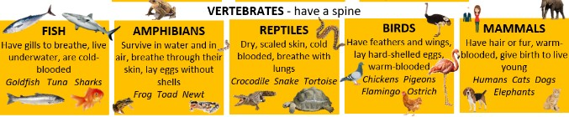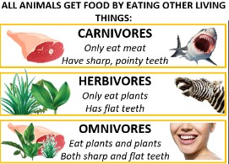  Year One:  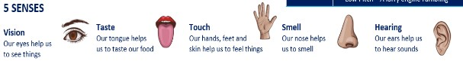 |  | 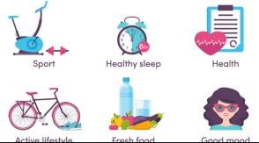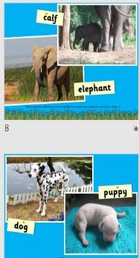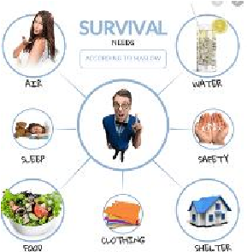  Year Two: | 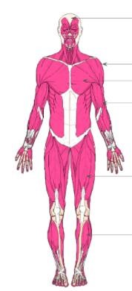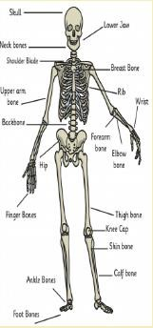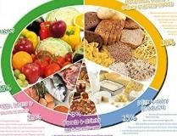  Year Three: | 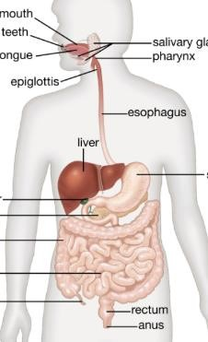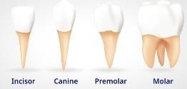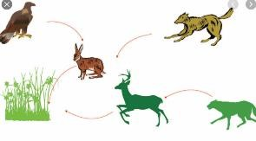Year Four: |  |  | 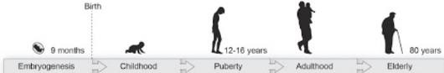  Year Five: | 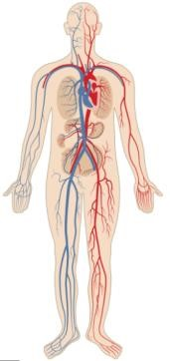  Year Six:

Biology - Living things and their habitats
 | Year 1 |  |  | Year 2 | Year 3 |  |  |  | Year 4 |  |  | Year 5 | Year 6
Knowledge |  |  |  | - explore and compare the differences between things that are living, dead, and things that have never been alive  - identify that most living things live in habitats to which they are suited and describe how different habitats provide for the basic needs of different kinds of animals and plants, and how they depend on each other  - identify and name a variety of plants and animals in their habitats, including microhabitats  - describe how animals obtain their food from plants and other animals, using the idea of a simple food chain, and identify and name different sources of food |  |  |  |  | - recognise that living things can be grouped in a variety of ways  - explore and use classification keys to help group, identify and name a variety of living things in their local and wider environment  - recognise that environments can change and that this can sometimes pose dangers to living things |  |  | - describe the differences in the life cycles of a mammal, an amphibian, an insect and a bird  - describe the life process of reproduction in some plants and animals | - describe how living things are classified into broad groups according to common observable characteristics and based on similarities and differences, including microorganisms, plants and animals  - give reasons for classifying plants and animals based on specific characteristics
Skills |  |  |  | Secure  - Can they match certain living things to the habitats they are found in?  - Can they explain the differences between living and non-living things?  - Can they describe some of the life processes common to plants and animals, including humans?  - Can they decide whether something is living, dead or non-living?  - Can they describe how a habitat provides for the basic needs of things living there?  - Can they describe a range of different habitats?  - Can they describe how plants and animals are suited to their habitat?  Extend  - Can they name some characteristics of an  animal that help it to live in a particular habitat?  - Can they describe what animals need to survive and link this to their habitats? |  |  |  |  | Secure  - Can they recognise that living things can be grouped in a variety of ways?  - Can they explore and use a classification key to group, identify and name a variety of living things? (plants, vertebrates, invertebrates)  - Can they compare the classification of common plants and animals to living things found in other places? (under the sea, prehistoric)  - Do they recognise that environments can change and this can sometimes pose a danger to living things? Extend  - Can they give reasons for how they have classified animals and plants, using their characteristics and how they are suited to their environment?  - Can they explore the work of pioneers in classification? (e.g. Carl Linnaeus)  - Can they name and group a variety of living things based on feeding patterns? |  |  | Secure  - Can they describe the differences in the life cycles of a mammal, an amphibians, an insects and a bird?  - Can they describe the life cycles of common plants?  - Can they explore the work of well know naturalists and animal behaviourists? (David Attenborough and Jane Goodall)  Extend  - Can they observe their local environment and draw conclusions about life-cycles, e.g.  plants in the vegetable garden or flower border?  - Can they compare the life cycles of plants and animals in their local environment with the life cycles of those around the world, e.g. rainforests? | Secure  - Can they explain the classification of living things into broad groups based on common observable characteristics? (five kingdoms of all living things, vertebrates, mammals, marsupials)  - Can they sub divide their original groupings and explain their divisions?  - Can they group animals into vertebrates and invertebrates?  Extend  - Can they explain why classification is important?  - Can they readily group animals into reptiles, fish, amphibians, birds and mammals?
Vocabul  ary |  |  |  | living, dependant, habitat, microhabitat, food chain, conditions |  |  |  |  | ecosystems, adaptation, nocturnal, organism, marine, diurnal, echolocation, vertebrate, |  |  | sexual, asexual reproduction, metamorphosis, | domain, kingdom, phylum, class, order, family, genus, species, characteristics
Expectation of skills progression |  |  |  | Year Two:  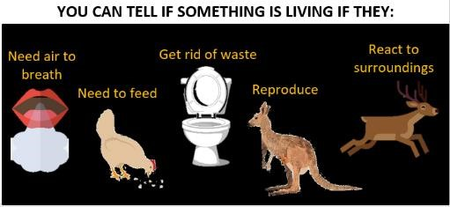  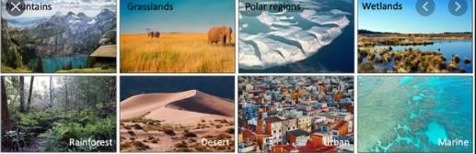  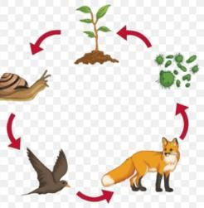 |  |  |  |  | Year Four:  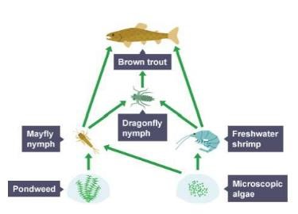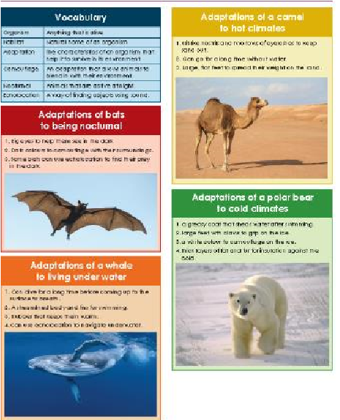 |  |  | Year Five:  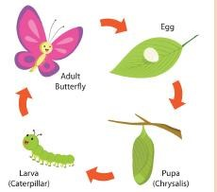  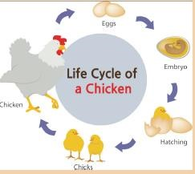 | 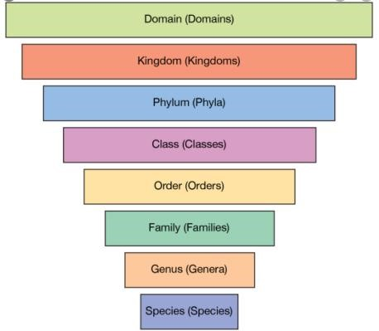  Year Six:
Biology - Plants
 | Year 1 |  |  | Year 2 | Year 3 |  |  | Year 4 |  |  |  | Year 5 | Year 6
Knowledge | - identify and name a variety of common wild and garden plants, including deciduous and evergreen trees  - identify and describe the basic structure of a variety of common flowering plants, including trees |  |  | - observe and describe how seeds and bulbs grow into mature plants  - find out and describe how plants need water, light and a suitable temperature to grow and stay healthy | - identify and describe the functions of different parts of flowering plants: roots, stem/trunk, leaves and flowers  - explore the requirements of plants for life and growth (air, light, water, nutrients from soil, and room to grow) and how they vary from plant to plant  - investigate the way in which water is transported within plants  - explore the part that flowers play in the life cycle of flowering plants, including pollination, seed formation and seed dispersal
Skills | Secure  - Can they name the petals, stem, leaf, bulb, flower, seed, stem and root of a plant?  - Can they identify and name a range of common plants and trees?  - Can they recognise deciduous and evergreen trees?  - Can they name the trunk, branches and root of a tree?  - Can they describe the parts of a plant (roots, stem, leaves, flowers)? Extend  - Can they name the main parts of a flowering plant? |  |  | Secure  - Can they describe what plants need to survive?  - Can they observe and describe how seeds and bulbs grow into mature plants?  - Can they find out & describe how plants need water, light and a suitable temperature to grow and stay healthy? Extend  - Can they describe what plants need to survive and link it to where they are found?  - Can they explain that plants grow and reproduce in different ways? | Secure  - Can they identify and describe the functions of different parts of flowering plants? (roots, stem/trunk, leaves and flowers)?  - Can they explore the requirement of plants  for life and growth (air, light, water, nutrients from soil, and room to grow)?  - Can they explain how they vary from plant to plant?  - Can they investigate the way in which water is transported within plants?  - Can they explore the part that flowers play in the life cycle of flowering plants, including pollination, seed formation and seed dispersal?
Vocabular  y | wild plants, garden plants, deciduous, evergreen, plant, leaf, root, leaves, bud, flowers, blossom, petals, stem, tree, trunk, branches, fruit, vegetables, bulb, seed |  |  | germination, reproduction, mature, survive, | flowering plant, germination, seed dispersal, adaptations, transpiration, functions, pollination
Expectation of skills progression | Year One:  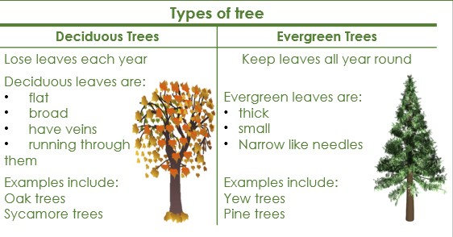  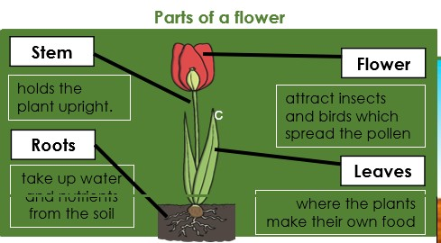 |  |  | Year Two:  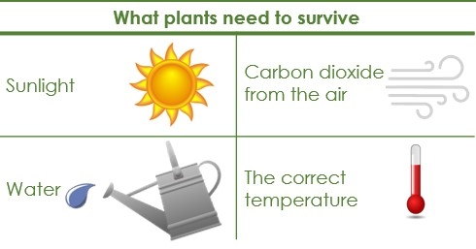  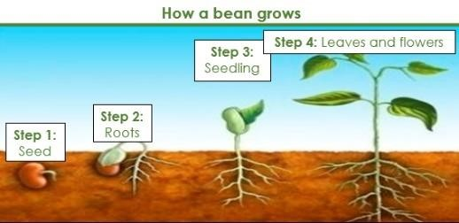 | Year Three:  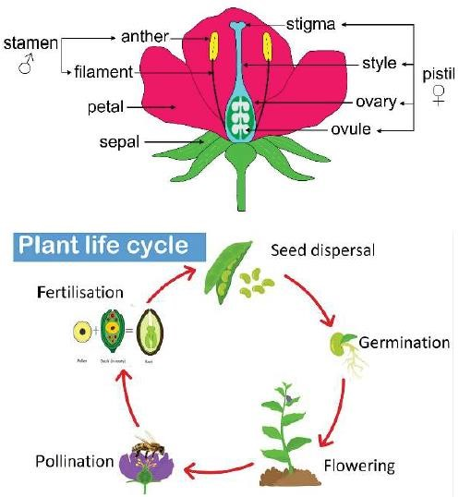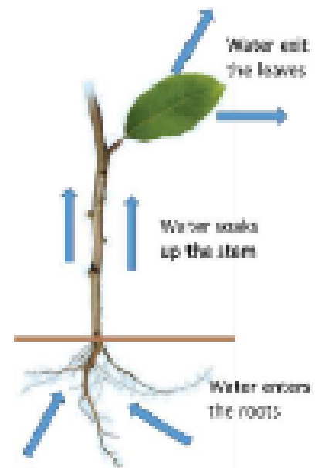

Biology - Evolution and inheritance
 | Year 1 | Year 2 | Year 3 | Year 4 | Year 5 |  |  | Year 6
Knowledge |  |  |  |  |  |  |  | - recognise that living things have changed over time and that fossils provide information about living things that inhabited the Earth millions of years ago  - recognise that living things produce offspring of the same kind, but normally offspring vary and are not identical to their parents  - identify how animals and plants are adapted to suit their environment in different ways and that adaptation may lead to evolution
Skills |  |  |  |  |  |  |  | Secure  - Can they give reasons for why living things produce offspring of the same kind?  - Can they give reasons for why offspring are not identical with each other or with their parents?  - Can they explain the process of evolution and describe the evidence for this?  - Can they begin to appreciate that variation in offspring over time can make animals more or less able to survive in particular environments?  - Can they talk about the life of Charles Darwin?  Extend  - Can they explain how some living things adapt to survive in extreme conditions?  - Can they analyse the advantages and disadvantages of specific adaptations, such as being on two rather than four feet?  - Can they begin to understand what is meant by DNA?
Voc  abul |  |  |  |  |  |  |  | evolution, fossilisation, homo sapiens, species, conservationist, adaptation, variation, inheritance, adaptation, traits
Expectation of skills progression |  |  |  |  |  |  |  | Year Six:  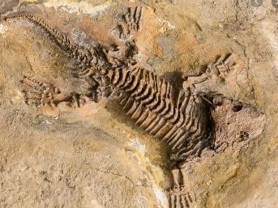  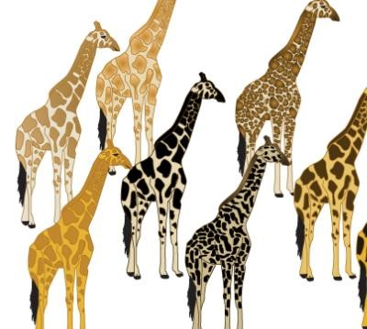  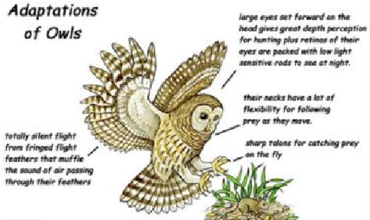

Chemistry - Materials
 | Year 1 | Year 2 | Year 3 | Year 4 | Year 5 | Year 6
Knowledge | - distinguish between an object and the material from which it is made  - identify and name a variety of everyday materials, including wood, plastic, glass, metal, water, and rock  - describe the simple physical properties of a variety of everyday materials  - compare and group together a variety of everyday materials on the basis of their simple physical properties | - identify and compare the suitability of a variety of everyday materials, including wood, metal, plastic, glass, brick, rock, paper and cardboard for particular uses  - find out how the shapes of solid objects made from some materials can be changed by squashing, bending, twisting and stretching | - compare and group together different kinds of rocks on the basis of their appearance and simple physical properties  - describe in simple terms how fossils are formed when things that have lived are trapped within rock  - recognise that soils are made from rocks and organic matter | - compare and group materials together, according to whether they are solids, liquids or gases  - observe that some materials change state when they are heated or cooled, and measure or research the temperature at which this happens in degrees Celsius (°C)  - identify the part played by evaporation and condensation in the water cycle and associate the rate of evaporation with temperature | - compare and group together everyday materials on the basis of their properties, including their hardness, solubility, transparency, conductivity  (electrical and thermal), and response to magnets  - know that some materials will dissolve in liquid to form a solution, and describe how to recover a substance from a solution  - use knowledge of solids, liquids and gases to decide how mixtures might be separated, including through filtering, sieving and evaporating  - give reasons, based on evidence from comparative and fair tests, for the particular uses of everyday materials, including metals, wood and plastic  - demonstrate that dissolving, mixing and changes of state are reversible changes  - explain that some changes result in the formation of new materials, and that this kind of change is not usually reversible, including changes associated with burning and the action of acid on bicarbonate of soda
Skills | Secure  - Can they distinguish between an object and the material from which it is made?  - Can they describe materials using their senses?  - Can they describe materials using their senses, using specific scientific words?  - Can they explain what material objects are made from?  - Can they explain why a material might be useful for a specific job?  - Can they name some different everyday materials? e.g. wood, plastic, metal, water and rock  - Can they sort materials into groups by a given criteria?  - Can they explain how solid shapes can be changed by squashing, bending, twisting and stretching? Extend  - Can they describe things that are similar and different between materials?  - Can they explain what happens to certain materials when they are heated, e.g. bread, ice, chocolate?  - Can they explain what happens to certain materials when they are cooled, e.g. jelly, heated chocolate? | Secure  - Can they describe the simple physical properties of a variety of everyday materials?  - Can they compare and group together a variety of materials based on their simple physical properties?  - Can they explore how the shapes of solid objects can be changed? (squashing, bending, twisting, stretching)  - Can they find out about people who developed useful new materials? (John Dunlop, Charles Macintosh, John McAdam)  - Can they identify and compare the suitability of a variety of everyday materials, including wood, metal, plastic, glass, brick, rock, paper, cardboard for particular uses?  - Can they explain how things move on different surfaces?  Extend  - Can they describe the properties of different materials using words like, transparent or opaque, flexible, etc.?  - Can they sort materials into groups and say why they have sorted them in that way?  - Can they say which materials are natural and which are man made?  - Can they explain how materials are changed by heating and cooling?  - Can they explain how materials are changed by bending, twisting and stretching?  - Can they tell which materials cannot be changed back after being heated, cooled, bent, stretched or twisted? | Secure  - Can they compare and group together  different rocks on the basis of their appearance and simple physical properties?  - Can they describe and explain how different rocks can be useful to us?  - Can they describe and explain the differences between sedimentary and igneous rocks, considering the way they are formed?  - Can they describe in simple terms how fossils are formed when things that have lived are trapped within rock?  - Can they recognise that soils are made from rocks and organic matter?  Extend  - Can they classify igneous and sedimentary rocks?  - Can they begin to relate the properties of rocks with their uses? | Secure  - Can they compare and group materials together, according to whether they are solids, liquids or gases?  - Can they explain what happens to materials when they are heated or cooled?  - Can they measure or research the temperature at which different materials change state in degrees Celsius?  - Can they use measurements to explain changes to the state of water?  - Can they identify the part that evaporation and condensation has in the water cycle?  - Can they associate the rate of evaporation with temperature? Extend  - Can they group and classify a variety of materials according to the impact of temperature on them?  - Can they explain what happens over time to materials such as puddles on the playground or washing hanging on a line?  - Can they relate temperature to change of state of materials? | Secure  - Can they compare and group together everyday materials on the basis of their properties, including hardness, solubility, transparency, conductivity (electrical and thermal), and response to magnets?  - Can they explain how some materials dissolve in liquid to form a solution?  - Can they describe how to recover a substance from a solution?  - Can they use their knowledge of solids, liquids and gases to decide how mixtures might be separated, including through filtering, sieving, evaporating?  - Can they give reasons, based on evidence for comparative and fair tests for the particular uses of everyday materials, including metals wood and plastic?  - Can they describe changes using scientific words? (evaporation, condensation)  - Can they demonstrate that dissolving, mixing and changes of state are reversible changes?  - Can they explain that some changes result in the formation of new materials, and that this kid of change is not usually reversible, including changes associated with burning and the action of acid on bicarbonate of soda?  - Can they use the terms ‘reversible’ and ‘irreversible’? Extend  - Can they describe methods for separating mixtures? (filtration,  distillation)  - Can they work out which materials are most effective for keeping us warm or for keeping something cold?  - Can they use their knowledge of materials to suggest ways to classify? (solids, liquids, gases)  - Cant hey explore changes that are difficult to reverse, e.g. burning, rusting and reactions such as vinegar with bicarbonate of soda?  - Can they explore the work of chemists who created new materials, e.g. Spencer Silver (glue on sticky notes) or Ruth Benerito (wrinkle free cotton)?
Voca  bular | absorbent , waterproof, material, properties, wood, plastic, metal, water, rock, magnetic, attract, repel, translucent, opaque | fabric, brittle, flexible, mixture, length, height, weight, design | igneous, sedimentary, metamorphic, rock cycle, chemical weathering, metamorphosis, intrusive, extrusive | solids, liquids, gases, state of matter, particles, non-newtonian fluid, properties, evaporation, condensation | pure substances, mixtures, formulation, insoluble, soluble, condensation, solubility, transparency, conductivity, physical changes, chemical changes, combustion, irreversible, insulation,
Expectation of skills  progression | 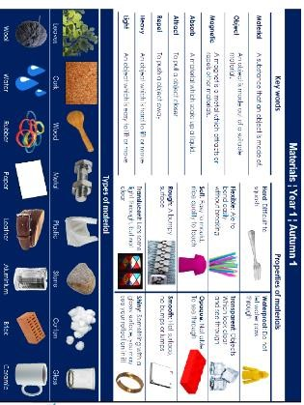  Year  One: | 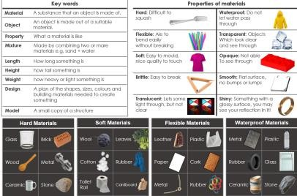  Year Two: | 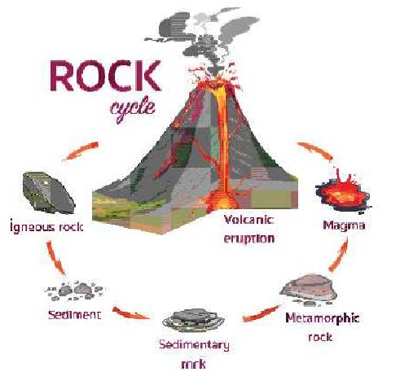  Year  Three: | 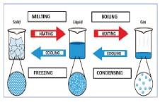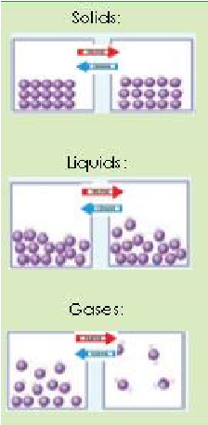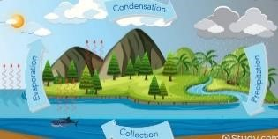  Year  Four: | 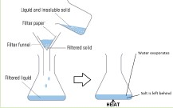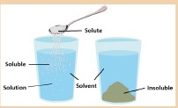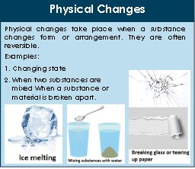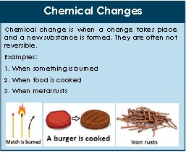  Year Five:

Physics - Forces
 | Year 1 | Year 2 | Year 3 |  |  |  | Year 4 |  | Year 5 | Year 6
Knowledge |  |  | - compare how things move on different surfaces  - notice that some forces need contact between 2 objects, but magnetic forces can act at a distance  - observe how magnets attract or repel each other and attract some materials and not others  - compare and group together a variety of everyday materials on the basis of whether they are attracted to a magnet, and identify some magnetic materials  - describe magnets as having 2 poles predict whether 2 magnets will attract or repel each other, depending on which poles are facing |  |  |  |  |  | - explain that unsupported objects fall towards the Earth because of the force of gravity acting between the Earth and the falling object  - identify the effects of air resistance, water resistance and friction, that act between moving surfaces  - recognise that some mechanisms including levers, pulleys and gears allow a smaller force to have a greater effect
Skills |  |  | Secure  - Can they compare how things move on different surfaces?  - Can they observe that magnetic forces can be transmitted without direct contact?  - Can they observe how some magnets attract or repel each other?  - Can they classify which materials are attracted to magnets and which are not?  - Can they notice that some forces need contact between two objects, but magnetic forces can act at a distance?  - Can they compare and group together a variety of everyday materials on the basis of whether they are attracted to a magnet?  - Can they identify some magnetic materials?  - Can they describe magnets have having two poles (N & S)?  - Can they predict whether two magnets will attract or repel each other depending on which poles are facing? Extend  - Can they investigate the strengths of different magnets and find fair ways to compare them? |  |  |  |  |  | Secure  - Can they explain that unsupported objects fall towards the earth because of the force of gravity acting between the earth and the falling object?  - Can they identify the effects of air resistance, water resistance and friction that act between moving surfaces?  - Can they recognise that some mechanisms, including levers, pulleys and gears, allow a smaller force to have a greater effect? Extend  - Can they describe and explain how motion is affected by forces? (including  gravitational attractions, magnetic attraction and friction)  - Can they design very effective parachutes?  - Can they work out how water can cause resistance to floating objects?  - Can they explore how scientists, such as Galileo Galilei and Isaac Newton helped to develop the theory of gravitation?
Vocab  ulary |  |  | attract, repel, compass, magnetic field, magnetic, non-magnetic, electromagnet, |  |  |  |  |  | contact forces, non-contact forces, up thrust, gravitational force, air resistance, water resistance, friction, magnetic force, Newtons, mechanism, accelerate
Expectation of skills progression |  |  | Year Three:  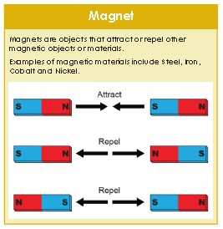 |  |  |  |  |  | Year Five:  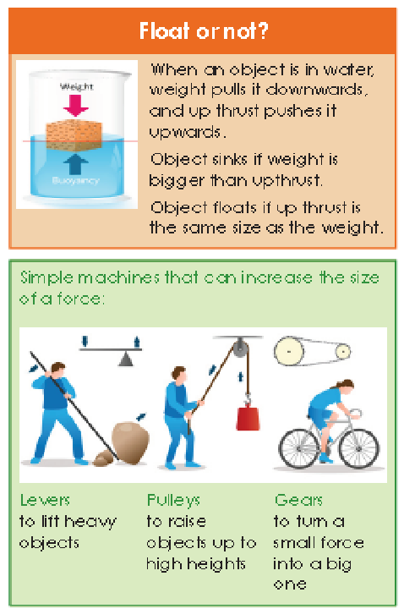

Physics - Light
 | Year 1 | Year 2 | Year 3 | Year 4 |  |  |  | Year 5 |  |  | Year 6
Knowledge |  |  | - recognise that they need light in order to see things and that dark is the absence of light  - notice that light is reflected from surfaces  - recognise that light from the sun can be dangerous and that there are ways to protect their eyes  - recognise that shadows are formed when  the light from a light source is blocked by an opaque object  - find patterns in the way that the size of shadows change |  |  |  |  |  |  |  | - recognise that light appears to travel in straight lines  - use the idea that light travels in straight lines to explain that objects are seen because they give out or reflect light into the eye  - explain that we see things because light travels from light sources to our eyes or from light sources to objects and then to our eyes  - use the idea that light travels in straight lines to explain why shadows have the same shape as the objects that cast them
Skills |  |  | Secure  - Can they recognise that they need light in order to see things?  - Can they recognise that dark is the absence of light?  - Can they notice that light is reflected from surfaces?  - Can they recognise that light from the sun can be dangerous and that there are ways to protect their eyes?  - Can they recognise that shadows are formed when the light from a light source is blocked by a solid object?  - Can they find patterns in the way that the size of shadows change? Extend  - Can they explain why lights need to be bright or dimmer according to need?  - Can they explain the difference between transparent, translucent and opaque?  - Can they explain why lights need to be bright or dimmer according to need?  - Can they make a bulb go on and off?  - Can they say what happens to the electricity when more batteries are added?  - Can they explain why their shadow changes when the light source is moved closer or further from the object? |  |  |  |  |  |  |  | Secure  - Can they explain how light travels?  - Can they explain how the human eye sees objects?  - Can they explain how different colours of light can be created?  - Can they use and explain how simple optical instruments work? (periscope, telescope, binoculars, mirror, magnifying glass, Newton’s first reflecting telescope)  - Can they explain changes linked to light (and sound)? Extend  - Can they use the ray model to explain the size of shadows?
V  o |  |  | source, reflection, refraction, periscope, lens |  |  |  |  |  |  |  | reflection, periscope, filters, shadows
Expectation of skills progression |  |  | 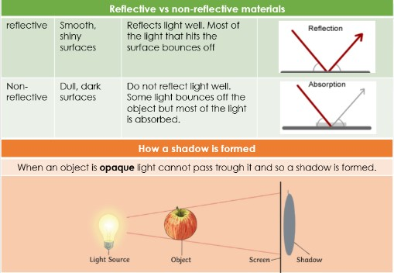Year Three: |  |  |  |  |  |  |  | Year Six:  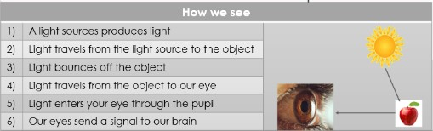

Physics - Electricity
 | Year 1 | Year 2 | Year 3 |  |  |  |  |  | Year 4 | Year 5 |  |  | Year 6
Knowledge |  |  |  |  |  |  |  |  | - identify common appliances that run on  electricity  - construct a simple series electrical circuit, identifying and naming its basic parts, including cells, wires, bulbs, switches and buzzers  - identify whether or not a lamp will light in a simple series circuit, based on whether or not the lamp is part of a complete loop with a battery  - recognise that a switch opens and closes a circuit and associate this with whether or not a lamp lights in a simple series circuit  - recognise some common conductors and  insulators, and associate metals with being good conductors |  |  |  | - associate the brightness of a lamp or the volume of a buzzer with the number and voltage of cells used in the circuit  - compare and give reasons for variations in how components function, including the brightness of bulbs, the loudness of buzzers and the on/off position of switches  - use recognised symbols when representing a simple circuit in a diagram
Skills |  |  |  |  |  |  |  |  | Secure  - Can they identify common appliances that run on electricity?  - Can they construct a simple series electric circuit?  - Can they identify and name the basic part  in a series circuit, including cells, wires, bulbs, switches and buzzers?  - Can they identify whether or not a lamp will light in a simple series circuit, based on whether or not the lamp is part of a complete loop with a battery?  - Can they recognise that a switch opens and closes a circuit?  - Can they associate a switch opening with whether or not a lamp lights in a simple series circuit?  - Can they recognise some common conductors and insulators?  - Can they associate metals with being good conductors? Extend  - Can they explain how a bulb might get lighter?  - Can they recognise if all metals are conductors of electricity?  - Can they work out which metals can be used to connect across a gap in a circuit?  - Can they explain why cautions are necessary for working safely with electricity? |  |  |  | Secure  - Can they identify and name the basic parts of a simple electric series circuit? (cells, wires, bulbs, switches, buzzers)  - Can they compare and give reasons for variation in how components function, including bulb brightness, buzzer volume and on/off position of switches?  - Can they explain how to make changes in a circuit?  - Can they explain the impact of changes in a circuit?  - Can they explain the effect of changing the voltage of a battery? Extend  - Can they make their own traffic light system or something similar?  - Can they explain the danger of short circuits?  - Can they explain what a fuse is?
V  oc |  |  |  |  |  |  |  |  | static electricity, static charge, electrical circuit, insulators, conductors, appliances, switch |  |  |  | voltage, brightness, volume, series, motor,
Expectation of skills progression |  |  |  |  |  |  |  |  | Year Four:  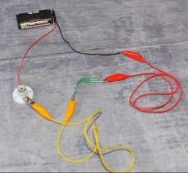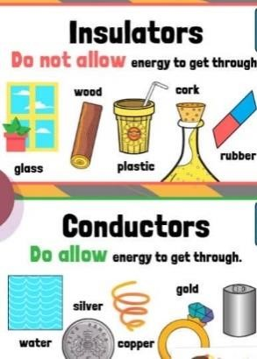 |  |  |  | Year Six:  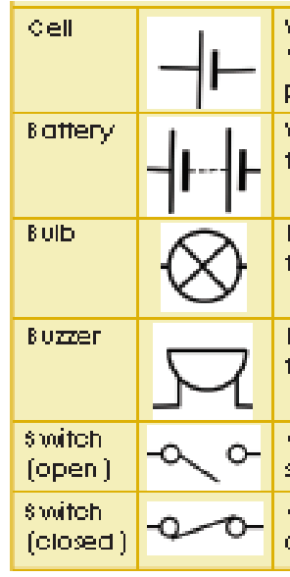
Physics - Sound
 | Year 1 | Year 2 | Year 3 |  |  |  |  |  | Year 4 | Year 5 |  |  | Year 6
Knowledge |  |  |  |  |  |  | - identify how sounds are made, associating some of them with something vibrating  - recognise that vibrations from sounds travel through a medium to the ear  - find patterns between the pitch of a sound and features of the object that produced it  - find patterns between the volume of a sound and the strength of the vibrations that produced it  - recognise that sounds get fainter as the distance from the sound source increases
Skills |  |  |  |  |  |  | Secure  - Can they describe a range of sounds and explain how they are made?  - Can they associate some sounds with something vibrating?  - Can they compare sources of sound and explain how the sounds differ?  - Can they explain how to change a sound (louder/softer)?  - Can they recognise how vibrations from sound travel through a medium to a ear?  - Can they find patterns between the pitch of a sound and features of the object that produce it?  - Can they find patterns between the volume of the sound and the strength of the vibrations that produced it?  - Can they recognise that sounds get fainter as the distance from the sound source increases?  - Can they explain how you could change the pitch of a sound?  - Can they investigate how different materials can affect the pitch and volume of sounds? Extend  - Can they explain why sound gets fainter or louder according to the distance?  - Can they explain how pitch and volume can be changed in a variety of ways?  - Can they work out which materials give the best insulation for sound?
Voc  abul |  |  |  |  |  |  | frequency, amplitude, vibrate, acoustics, decibels, Hertz, pitch, eco-location, percussion, volume
Expectation of skills progression |  |  |  |  |  |  | 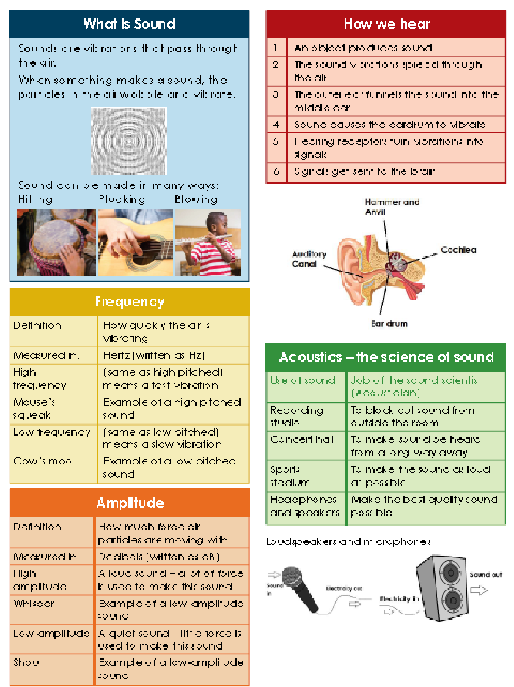  Year  Four:

Physics – Earth and space
 | Year 1 | Year 2 |  |  | Year 3 | Year 4 | Year 5 | Year 6
Knowledge | - observe changes across the 4 seasons  - observe and describe weather associated with the seasons and how day length varies |  |  |  |  |  | - describe the movement of the Earth and other planets relative to the sun in the solar system  - describe the movement of the moon  relative to the Earth  - describe the sun, Earth and moon as approximately spherical bodies  - use the idea of the Earth’s rotation to explain day and night and the apparent movement of the sun across the sky
Skills | Secure  - Can they observe changes across the four seasons?  - Can they name the four seasons in order?  - Can they observe and describe weather associated with the seasons?  - Can they observe and describe how day length varies?  Extend  - Can they observe features in the environment and explain that these are related to a specific season?  - Can they observe and talk about changes in the weather?  - Can they talk about weather variation in different parts of the world? |  |  |  |  |  | Secure  - Can they identify and explain the movement of the Earth and other plants relative to the sun in the solar system?  - Can they explain how seasons and the associated weather is created?  - Can they describe and explain the movement of the Moon relative to the Earth?  - Can they describe the sun, earth and moon as approximately spherical bodies?  - Can they use the idea of the earth’s rotation to explain day and night and the apparent movement of the sun across the sky? Extend  - Can they compare the time of day at different places on the earth?  - Can they create shadow clocks?  - Can they begin to understand how older civilizations used the sun to create astronomical clocks, e.g. Stonehenge?  - Can they explore the work of some scientists? (Ptolemy, Alhazen, Copernicus)
Voca  bular | sleet, hail, fog, season, summer, winter, autumn, spring, weather, hibernation, forecast |  |  |  |  |  | lunar, solar, eclipses, constellations, galaxies, universe, astronomy, Milky Way, astronomer, heliocentric, geocentric, hemisphere, orbit, axis
Expectation of skills progression | Year One:  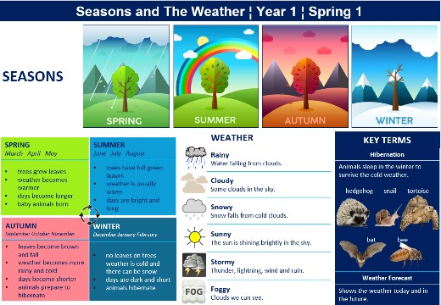 |  |  |  |  |  | Year Five:  