POLICY AMENDMENT DUE TO INTERIM HEADTEACHER
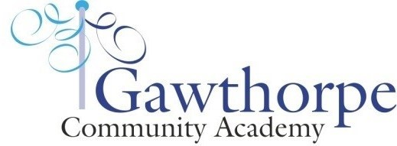

Name of policy:

Date of review: January 2022

This policy has been reviewed and there are no changes necessary at this time. The policy has already been agreed by the Governing Body.
It will be reviewed in line with the review timetable.

Signed by headteacher: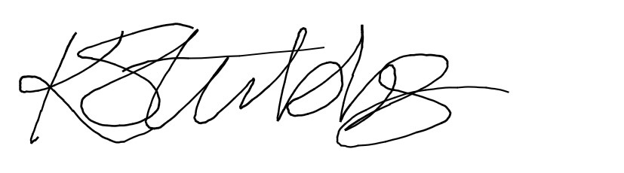
12.1.22

