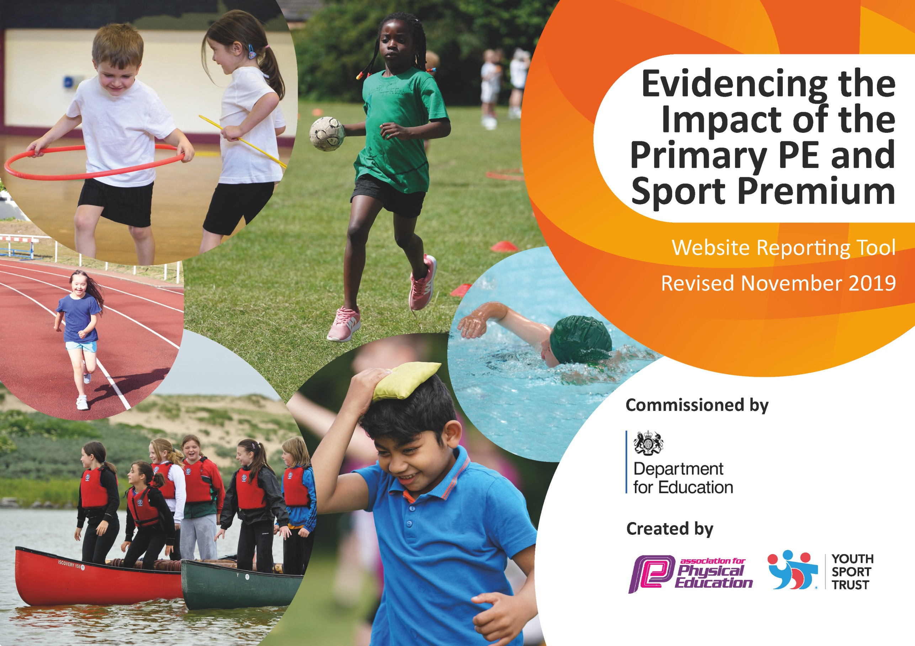
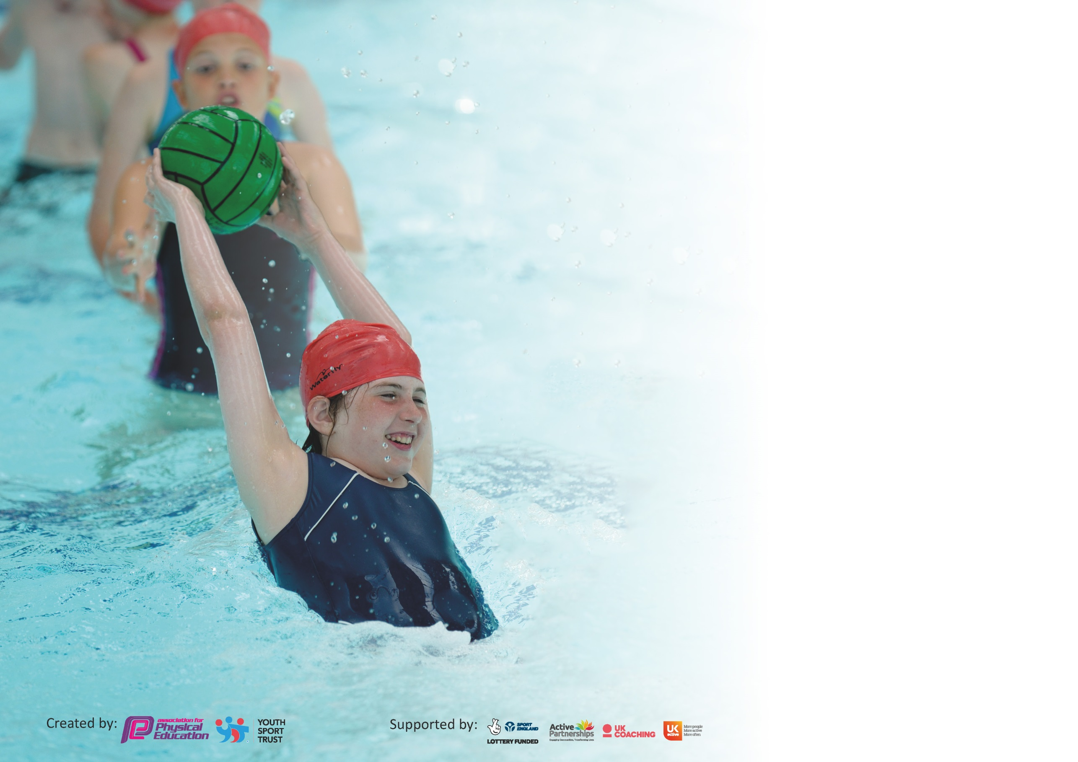

It is important that your grant is used effectively and based on school need. The Education Inspection Framework (Ofsted 2019 p64) makes clear there will be a focus on ‘whether leaders and those responsible for governors all understand their respective roles and perform these in a way that enhances the effectiveness of the school’.

Under the Quality of Education criteria (p41) inspectors consider the extent to which schools can articulate their curriculum (INTENT), construct their curriculum (IMPLEMENTATION) and demonstrate the outcomes which result (IMPACT).

To assist schools with common transferable language this template has been developed to utilise the same three headings which should make your plans easily transferable between working documents.

Schools must use the funding to make additional and sustainable improvements to the quality of Physical Education, School Sport and Physical Activity (PESSPA) they offer. This means that you should
use the Primary PE and Sport Premium to:

- Develop or add to the PESSPA activities that your school already offer
- Build capacity and capability within the school to ensure that improvements made now will benefit pupils joining the school in future years

Please visit gov.uk for the revised DfE guidance including the 5 key indicators across which schools should demonstrate an improvement. This document will help you to review your provision and to report your spend. DfE encourages schools to use this template as an effective way of meeting the reporting requirements of the Primary PE and Sport Premium.

We recommend you start by reflecting on the impact of current provision and reviewing the previous spend.

Schools are required to publish details of how they spend this funding as well as on the impact it has on pupils’ PE and sport participation and attainment by the end of the summer term or by 31st July 2020 at the latest.

We recommend regularly updating the table and publishing it on your website throughout the year. This evidences your ongoing self-evaluation of how you are using the funding to secure maximum, sustainable impact. Final copy must be posted on your website by the end of the academic year and no later than the 31st July 2020. To see an example of how to complete the table please click HERE.

Support for review and reflection - considering the 5 key indicators from DfE, what development needs are a priority for your setting and your pupils now and why? Use the space below to reflect on previous spend and key achievements and areas for development.

Key achievements to date until July 2019: | Areas for further improvement and baseline evidence of need:
3 staff completing the level 5 PE specialist qualification and 1 currently carrying out Level 6. Developed staff confidence and able to pass this on and create resources for others.  Clear PE strategy and progression from year to year incorporating health and well being.  Children having lessons delivered by PE specialists, including an international gym coach.  Quality play mark gained for active lunch times.  Active Lunch time and after school clubs allow for all children to gain 30 minutes of daily exercise. Each half term 20 children attend KS2 multi sports and 20 children attend KS2 multi sports with a wide range of children attending. New areas set up in the playground for sports such as football and dodgeball to be played.  Qualified to represent Wakefield at the West Yorkshire games in Gymnastics through having a specialist gym teacher.  Over the past 3 years 30 pupils have joined the local dance school that our specialist dance teacher runs. Since starting this over half still attend. Opportunities to perform in various environments such as the Town hall and local precinct.  The profile of PE, sport and exercise has raised with children eager to bring out of school achievements into our weekly Friday celebration assembly. See board in the hall and excel spreadsheet record of clubs.  Developed a way of improving performance with the use of technology- we purchased half a class set of tablets. Filming and photographing lessons by adults and children has enhanced performance, proved a good assessment tool and creative ways to start and end lessons.  Whole school boost and improvement with the purchase of hat, t-shirt and shorts for all children. A significant reduction in the number of children forgetting their kit in each class. Pre purchase there was an average of 5 children per class forgetting kit. Post purchase there is an average of 1 child per class. The children like their kit and look smart representing the academy and during PE Lessons. Due to the impact we hope to provide at least a t-shirt each year.  The continued weekly kidnetics programmed sessions have seen the vocabulary and understanding of children improve as well as their ABC’S.  Gawthorpe to host annual potted sports for KS1. Invite 9 local schools. Due to premium the event is now in its 6th year.  KS1 have been able to participate in MAT event at Thornes co-hosted by MAT schools. Using the premium to purchase transport has made this possible to further the opportunities for KS1 giving the children a chance to work towards something. They can practise and develop in their PE lessons.  Offer practical and classroom workshops to challenge stereotypes and look at fairness within PE and sport. Totally Runnable benchmarked our children for fitness levels and delivered workshops with identified classes.  Zoom Virtual PE lessons through C-19. 4 a week delivered by our providers and PE specialist. CPD opportunity for staff.  Encouraged and motivated more children to attend junior park run. 30 children have attended this year. We have encouraged those children who do not do any extracurricular activities as well as those who are striving.  Film and photograph lessons (Cross curricular links) To motivate, inspire and include any children who are unable to take part in the physical part of the lesson. Excellent opportunity for CPD to video staff teaching to share.  The enthusiasm of children to join in with the challenges that we set during lockdown is commendable. It might not have a monetary value but it is because of the high profile of P.E that children wanted to join in and be part of the sock challenge and dance challenge. We have provided daily challenges to keep the interest going throughout the lockdown and onwards. It has giving the children the opportunity to showcase their own challenges by designing and sending them in for filming. See twitter.  We now have a Youtube channel- Keep moving with Gawthorpe. | Continue to promote and push health and well- being especially following C-19. This will be the main focus moving into September to Christmas. Discussion and decisions still to be made as to be best way to implement this.  Introduction of swimming in lower KS2 as our record of none swimmers to swimmers in year 6 is good but we have found by the time children get to Year 6 some of the none swimmers have a fear of water. This year has been higher than normal due to C-19  Continue to develop a scheme to match our progression grids that is specific to the needs of our children. This will support staff who may not be as confident teaching PE. Individual lesson plans with clear structure and whole school intention.  OAA opportunities both on site and away from the site. This is a skill that has been identified as needed further development and there has been limited opportunity.

Meeting national curriculum requirements for swimming and water safety.
What percentage of your current Year 6 cohort swim competently, confidently and proficiently over a distance of at least 25 metres?  N.B. Even though your pupils may swim in another year please report on their attainment on leaving  primary school at the end of the summer term 2020. | ***Cut short due to pool closure and C-19. Potential to get % up.  68%
What percentage of your current Year 6 cohort use a range of strokes effectively [for example, front crawl, backstroke and breaststroke]? | ***Cut short due to pool closure and C-19. Potential to get % up.  68%
What percentage of your current Year 6 cohort perform safe self-rescue in different water-based situations? | ***Cut short due to pool closure and C-19. Potential to get % up.  68%
Schools can choose to use the Primary PE and Sport Premium to provide additional provision for swimming but this must be for activity over and above the national curriculum requirements. Have you used it in this way? | No but we continue to look into using the premium to do over and above swimming next year.

Action Plan and Budget Tracking
Capture your intended annual spend against the 5 key indicators. Clarify the success criteria and evidence of impact that you intend to measure to evaluate for pupils today and for the future.

Academic Year: 2019/20 | Total fund allocated: ££17,790.00 | Date Updated: 4.07.20
Key indicator 1: The engagement of all pupils in regular physical activity – Chief Medical Officer guidelines recommend that primary school pupils undertake at least 30 minutes of physical activity a day in school |  |  |  | Percentage of total allocation:
 |  |  |  | 25%
Intent | Implementation |  | Impact
Your school focus should be clear what you want the pupils to know and be able to do and about  what they need to learn and to  consolidate through practice: | Make sure your actions to achieve are linked to your intentions: | Funding allocated: | Evidence of impact: what do pupils now know and what can they now do? What has changed?: | Sustainability and suggested next steps:
To get children to understand the importance of raising heart rate, moving more and understand the impact it can have on their health and well being.  Improve general fitness and the awareness of its benefit.  To promote children being active at lunch times and breaks | 2X 15minute slots for each class added into each week’s timetable to start with. To run/walk/move around the playground.  Half termly intra sports used to motivate and check how children are getting on. Recording laps completed.  Sort date for benchmark.  Monitor data and put in interventions where needed.  Totally Runnable to benchmark children with a challenge 15 minutes run at the start of the school year. They will publish findings (ask for these) and then come back at the end of the school year to monitor progress.  Playground markings- liaise with school council to design/select markings.  Obtain estimates prices.  Organise access for company to complete work.  Teach children games and examples of how to use the markings.  Monitor use of markings through pupil voice and observations.  New plans and quote to be drawn up.  Delayed sure to C-19  Due to start hopefully 20th July 2020. | £1,350.00  £3,100 SUBJECT TO CHANGE. | Children in Year 2, 3 and 6 consistently carried out the initiative twice a week and the children reminded the teachers.  They would say, ‘It is our run!’ They were eager to make up sessions if they had to be missed.  It also helped social interactions and well being. Some children chose to walk round the track and chat to their friends. Once back in the classroom they were ready to learn as they had had their extra interaction.  Due to C-19 we have not had our end of year review by Totally runnable so the true results and impact are not available. We have offered 4 high intensity virtual PE and fitness lessons per week throughout this time via zoom. Also daily challenges to help with activity and fitness.  TO FOLLOW.  Playground marking have been delayed due to COVID 19. Markings will be completed week beginning 20/07/2020 and use will be monitored in the Autumn term.  . | To definitely continue this next year and into the future. Possibly up this to 3 times or 4 times a week.  Possibly adapt what we do for the 15 minutes to ensure the children are getting the maximum benefit.
Key indicator 2: The profile of PESSPA being raised across the school as a tool for whole school improvement |  |  |  | Percentage of total allocation:
 |  |  |  | %
Intent | Implementation |  | Impact
Your school focus should be clear what you want the pupils to know and be able to do and about  what they need to learn and to  consolidate through practice: | Make sure your actions to achieve are linked to your intentions: | Funding allocated: | Evidence of impact: what do pupils now know and what can they now do? What has changed?: | Sustainability and suggested next steps:
To motivate and inspire the children to wear their badge with pride.  Ensure all children feel comfortable and confident when participating.  To boost the profile and professionalism of PE & sport.  Helping the children understand the value of PE, health and sports whilst recognising what they can achieve at various levels.  To challenge the thinking of the children. Raise awareness of gender and sport while relating it to the values and curriculum. Think about what sort of children we want to  For children to recognise the importance of improving and continuing to develop over time in order to remember more, know more and achieve more. An opportunity to revisit and instantly improve and reflect. | Whole school to be provided with a new Academy PE T-SHIRT.  Speak to the provider from last year then price up, size up and purchase the tops.  Tops changed to navy and this will remain this colour. Much better quality and wearable.  Children in all classes to come into school in their PE KIT on their PE day.  Set expectations re tracksuit etc when it is cold weather.  Totally Runnable stereotype workshops.  Allocate classes and workshops depending on need within each class.  Discuss and revisit messages they have discussed.  Also use as CPD for staff.  Ipads to replace tablets in order to create videos and sporting analysis following on from last year. Tablets were not 100% compliant with apps and software.  Price up iPad.  Sort apps.  Train staff and send information to parents re creations. | £1,612.50  £1,700 APPROX  Postponed due to c-19 and waiting for playground markings. | Due to the fact that children can come into school in their kit has seen a significant improvement. More time for lessons as no changing time at either side and no forgotten kit. Possibly 1 or 2 in a half term minimum.  Some children tried to come in fancy tracksuits but this has been monitored and sorted by proving them with a spare school jumper and a text home.  HALF A YEAR ATTAINMENT DUE TO C-19  Dance  Y1- WT 13% E62% GD25%  Y2- WT 10% E65% GD25%  Y3- WT16% E 64% GD 20%  Y4- WT 11% E 56% GD 33%  Y5- WT/B 16% E64% GD30%  Y6- WT6% E71% GD23%  Gym  Y1- WT 15% E52% GD33%  Y2- WT/B 17% E 37% GD 46%  Y3- WT 16% E 53% GD 30%  Y4- WT 18% E51% GD 30%  Y5- WT/B 17% E 63% GD 20%  Y6- WT 10% E 56% GD 34%  Games  Y1- WT/B 12% E63% GD25 %  Y2- WT/B16% E71% GD13%  Y3- WT13% E69% GD 20%  Y4- WT 16% E65% GD19%  Y5- WT/B 16% E 68% GD 16%  Y6- WT 6% E 57% GD 37%  Health, social, evaluation OAA.  Y1- WT16% E71% GD13%  Y2- WT/B16% E71% GD13%  Y3- WT13% E69% GD 20%  Y4- WT 10% E73% GD17%  Y5- WT/B 16% E 68% G16%  Y6- WT 6% E 68% GD 26%  A higher % of children in YEAR 1,2 AND 3 have made increased progressed and attainment. This is due to us seeing the impact of the consistent approach that is starting to come through right from Reception class. More children at greater depth due to the challenge and use of the progression grids. This has help throughout school to ensure there is enough challenge. | Continue to promote importance of wearing kit and how it makes you feel. Children will be provided with a top to demonstrate the value and importance of PE. They can use all the tops and kit they have received and pass old ones to siblings. As year 6 leave they have handed kit back to pass on to other children.  It really has made a big difference to the children and how they look and feel.

Key indicator 3: Increased confidence, knowledge and skills of all staff in teaching PE and sport |  |  |  | Percentage of total allocation:
 |  |  |  | 41%
Intent | Implementation |  | Impact
Your school focus should be clear | Make sure your actions to | Funding | Evidence of impact: what do | Sustainability and suggested
what you want the pupils to know | achieve are linked to your | allocated: | pupils now know and what | next steps:
and be able to do and about | intentions: |  | can they now do? What has
what they need to learn and to |  |  | changed?:
consolidate through practice:
To upskill staff and help them build a bank of ideas to ensure the children are receiving the highest quality lessons, that are tailored to their needs with high expectations.  To ensure correct vocabulary is being used within lessons. Vocabulary to be consolidated and built upon. | Continued use of gym, kinetics and dance specialist  Ensure monitoring of gym, kinetics and dance specialist- speak to the staff regularly and observe lessons.  Pupil voice interviews and questionnaires to be completed.  Ensure specialists are working with at least 2 classes and staff.  At least 2 staff meetings for sports leader to implement additional training.  Ensure time for staff to work together.  Ensure everyone is tracking progress and planning using the tool introduced last year.  Begin designing lesson plans to run alongside progression grids.  C-19- ALL staff and children having access via zoom and daily challenges. 4 zooms per week. One dance specific, 2 fitness and dance, one games related.  Weekly gym tutorials uploaded.  All by our specialists that would be in school. | £1,950  £2,590  £2,695  TOTAL=7,295 | The vocabulary of the children is reflecting that of the teacher. We are now seeing a consistent theme running through school and a clear progression within classes and key stages.  Around 18 children attend the dance school of our dance specialist.  15 pupils attend after school gym club with our gym specialist.  Clear progression within lessons and year groups with teacher confidence increased. Heavy focus on the 4 corners relating to the FA model. Technical/skills, physical, social and psychological implications and focus.  ALL Staff confident in completing assessment and using it as a planning tool for further lessons while they continue liaising with specialists.  Zoom lessons have proved useful CPD for ideas within a restricted space in a short amount of time. Teachers are able to access these from school and home. | Planning sheets to supplement progression grids be fully completed by next year. Some are ready to go from September for KS1. To have a full set of plans by the end of next year.  Monitor lessons frequently and adapt according.  School staff to deliver more with assistance, guidance and plans from PE specialists.
Key indicator 4: Broader experience of a range of sports and activities offered to all pupils |  |  |  | Percentage of total allocation:
 |  |  |  | 10%
Intent | Implementation |  | Impact
Your school focus should be clear | Make sure your actions to | Funding | Evidence of impact: what do | Sustainability and suggested
what you want the pupils to know | achieve are linked to your | allocated: | pupils now know and what | next steps:
and be able to do and about | intentions: |  | can they now do? What has
what they need to learn and to |  |  | changed?:
consolidate through practice:
To motivate and give children experience of alternative ways to exercise. The intention to promote alternative methods to be fit and healthy as well as to develop technical skills and social skills.  Give children the opportunity and direction to access a variety of activities in and out of school. | Purchase some additional resources.  Including class boxercise set,  trampets and pompoms.  Netball posts order for netball club.  Monitor the engagement and impact.  Pupil voice.  To offer alternative after school clubs to engage a wider range of children.  Introduce a dance and fitness club as well as multi sports and sport focus clubs.  Monitor registers and sign up of clubs each half term.  Build links with local community to signpost children.  C-19 Done via zoom and daily challenges. | £946.55  £240.00 | Multi sports club still heavily attended by boys.  Autumn 1 –  KS1- 15 G-5 B-10  KS2- 20 G-3 B- 17  Autumn 2-  KS1- 21 G-9 B-12  KS2- 19 G- 3 B- 16  Spring 1-  KS1-14 G-3 B-11  KS2-17 G-1 B-16  Spring 2-  KS1- 17 G-3 B-14  KS2- 19 G-2 B-17  DANCE AND FITNESS (NEW CLUB)  ALL CLASSES.  Autumn 1 –TOTAL 22  G-20 B- 2  Autumn 2-TOTAL 31  G- 21 B- 10  Spring 1-TOTAL 30  G-23 B-7  Spring 2-TOTAL 31  G-2 19 B-12  Netball KS2  Autumn 1- Total 10  G-6 B-4  Autumn 2- Total 10  G-6 B-4  By carrying out a pupil voice and starting a new club this has dramatically increased girls participation in extra curricular activity whilst maintaining and increasing boys levels.  Last year we has a total 45 girls attending after school activity, this could have been the same ones attending each club and could be counted numerous times.  This year using the same system the amount would have doubled.  Looking at our achievements wall children are increasingly taking up and are motivated to try new sports and exercise opportunities out of school. | Continue to attend meetings with high school to take up opportunities provided.  Continue to be proactive with the opportunities that the school games offer.  Ask pupils what activities they would like to take part in and introduce these within lessons and after school club.  Trial different after school clubs. Staff to gain qualifications in new sports and exercise such as boxercise. CPD opportunities and qualifications to be utilised.  Continue to increase participation of both boys and girls by offering a variety of activities and a varied curriculum. Continue to ask and research.  Look into residential that offer OAA and a variety of opportunities.

Key indicator 5: Increased participation in competitive sport |  |  |  | Percentage of total allocation:
 |  |  |  | 13%
Intent | Implementation |  | Impact
Your school focus should be clear | Make sure your actions to | Funding | Evidence of impact: what do | Sustainability and suggested
what you want the pupils to know | achieve are linked to your | allocated: | pupils now know and what | next steps:
and be able to do and about | intentions: |  | can they now do? What has
what they need to learn and to |  |  | changed?:
consolidate through practice:
Introduce further competitive fixtures. To allow those who don’t always get opportunity at clubs.  To develop confidence and implement skills children have established in a competitive situation.  To have the opportunity to display values and skills in a wider stage. | 6 intra sports events for the whole school. 1 per half term. Different themes this year based on feedback from last year. Purchase new equipment.  Offer additional competition for KS1children  Gawthorpe to host annual potted sports for KS1 again in June. Invite 9 local schools.  Devise new stations. Prepare paperwork and purchase new equipment.  Attend and contribute half termly events organised between local schools.  Purchase new universal kit to compete in any sports fixtures.  KS1 to participate in MAT event at Thornes co-hosted by MAT schools. Book venue and buses. Liaise with other schools.  New equipment and buses.  Price up kit. | £2,101.70  £258.25 | 3 intra sports events took place within school where children demonstrated their fitness as this had been identified as an area to improve. This is linked to indicator 1.  New equipment purchased in preparation for the events will hopefully boost engagement and participation when the competitions are held.  Other events cancelled due to C-19 | These two events will hopefully happen again next year with the intention to do something for KS2.  Establish further fixtures to attend throughout the year. Contine to build links with schools and take up school games offers.

Signed off by
Head Teacher:
Date:
Subject Leader:
Date:
Governor:
Date:

